SQL:

SyllabusGenerator:

**Database and Table creation:**

USE master;

GO

IF DB_ID('SyllabusGenerator') IS NOT NULL

DROP DATABASE SyllabusGenerator;

GO

CREATE DATABASE SyllabusGenerator;

GO

USE SyllabusGenerator;

CREATE TABLE Department (

DepartmentID INT PRIMARY KEY IDENTITY,

DepartmentName VARCHAR(255) NOT NULL,

DepartmentCode VARCHAR(20) NOT NULL UNIQUE

);

CREATE TABLE Professor (

ProfessorID INT PRIMARY KEY IDENTITY,

DepartmentID INT REFERENCES Department (DepartmentID),

Name VARCHAR(100) NOT NULL,

EmailID VARCHAR(100) NOT NULL UNIQUE,

ContactNumber varchar(20) NOT NULL

);

CREATE TABLE ProgramChair (

ProgramChairID INT PRIMARY KEY IDENTITY,

DepartmentID INT REFERENCES Department (DepartmentID),

Name VARCHAR(100) NOT NULL,

EmailID VARCHAR(100) NOT NULL UNIQUE,

ContactNumber varchar(20) NOT NULL

);

CREATE TABLE Course (

CourseID INT PRIMARY KEY IDENTITY,

DepartmentID INT REFERENCES Department (DepartmentID),

ProfessorID INT REFERENCES Professor (ProfessorID),

CourseCode VARCHAR(50) NOT NULL UNIQUE,

CourseName VARCHAR(50) NOT NULL,

CourseType VARCHAR(10) NOT NULL

);

CREATE TABLE TextBook (

TextBookID INT PRIMARY KEY IDENTITY,

TextBookName VARCHAR(255) NOT NULL,

Category VARCHAR(255) NOT NULL,

);

CREATE TABLE Syllabus (

SyllabusID INT PRIMARY KEY IDENTITY,

CourseID INT REFERENCES Course (CourseID),

ProfessorID INT REFERENCES Professor (ProfessorID),

TextBookID varchar(100) Default Null,

Semester VARCHAR(60) NOT NULL,

LearningObjective VARCHAR(max) NOT NULL,

prerequisite varchar(max) DEFAULT NULL

);

CREATE TABLE SyllabusAudit (

SyllabusAuditID INT PRIMARY KEY IDENTITY,

SyllabusID INT ,

CourseID INT ,

ProfessorID INT ,

TextBookID varchar(100) ,

Semester VARCHAR(60) ,

LearningObjective VARCHAR(max) ,

prerequisite varchar(max) ,

Audit_Action varchar(10) ,

Action_By INT ,

Action_At DATETIME ,

Remark Varchar(max)

);

CREATE TABLE CourseSchedule (

CourseScheduleID INT PRIMARY KEY IDENTITY,

SyllabusID INT REFERENCES Syllabus (SyllabusID),

CourseID INT REFERENCES Course (CourseID),

Module Varchar(20) NOT NULL,

CourseContents Varchar(max) NOT NULL,

StartDate Date NOT NULL,

EndDate Date NOT NULL

);

SET IDENTITY_INSERT Department ON;

INSERT INTO Department (DepartmentID, DepartmentName, DepartmentCode) VALUES

(1, 'Information Technology', 'IFT'),

(2, 'Computer Science','CS'),

(3, 'Software Engineering','SE'),

(4, 'Computer Engineering', 'CE'),

(5, 'Construction Management', 'CMT');

SET IDENTITY_INSERT Department OFF;

SET IDENTITY_INSERT Professor ON;

INSERT INTO Professor (ProfessorID, DepartmentID, Name,EmailID,ContactNumber) VALUES

(1, 1, 'Robert Rucker','RobertRucker@asu.edu','6022221111'),

(2, 1,'Asmaa Elbadrawy','AsmaaElbadrawy@asu.edu','6023331111'),

(3, 1,'Dinesh Sthapit','DineshSthapit@asu.edu','6024441111'),

(5, 2, 'Chris Bryan','ChrisBryan@asu.edu','6022222222'),

(6, 2, 'Hasan Davulcu','HasanDavulcu@asu.edu','6023332222'),

(7, 2, 'Samira Ghayekhloo','SamiraGhayekhloo@asu.edu','6024442222');

SET IDENTITY_INSERT Professor OFF;

SET IDENTITY_INSERT ProgramChair ON;

INSERT INTO ProgramChair (ProgramChairID, DepartmentID, Name,EmailID,ContactNumber) VALUES

(1, 1, 'Tatiana Walsh','TatianaWalsh@asu.edu','6021111111'),

(2, 2, 'Dont Know','DontKnow@asu.edu','6021112222'),

(3, 3, 'Srividya Bansal','SrividyaBansal@asu.edu','6021113333'),

(4, 4, 'John Doe','JohnDoe@asu.edu','6021114444'),

(5, 5, 'Abc Xyz','AbcXyz@asu.edu','6021115555');

SET IDENTITY_INSERT ProgramChair OFF;

SET IDENTITY_INSERT course ON;

INSERT INTO course (CourseID, DepartmentID, ProfessorID,CourseCode,CourseName,CourseType) VALUES

(1, 1, 1,'IFT530','Advanced Database Management Systems','In-Person'),

(2, 1,2, 'IFT511','Analyzing Big Data','In-Person'),

(3, 1,1, 'IFT430','Database Management System','In-Person'),

(4, 1,2, 'IFT411','Fundamentals of Python','In-Person'),

(5, 1,3, 'IFT510','Principles of Computer Information and Technology','In-Person');

SET IDENTITY_INSERT course OFF;

SET IDENTITY_INSERT TextBook ON;

INSERT INTO TextBook (TextBookID, TextBookName,Category) VALUES

(1, 'Murachs SQL server for developers','Database'),

(2, 'Halpin, Morgan( 2008) Information Modeling and Relational Databases 2nd edition, Kaufman','Database'),

(3, 'Data Science for Business by F. Provost and T. Fawcett','DataScience'),

(4, 'Mathematical Statistics with Applications, 7th edition, by Wackerly, Mendenhall, and Scheaffer, Brooks/Cole, Cengage Learning, 2008.','DataScience'),

(5, 'Basics of Python','Language');

SET IDENTITY_INSERT TextBook OFF;

SET IDENTITY_INSERT Syllabus ON;

INSERT INTO Syllabus (SyllabusID, CourseID, ProfessorID,textbookid,Semester,LearningObjective, prerequisite) VALUES

(1, 1, 1,'1,2','Fall','1.Understand the principles of conceptual modeling,2.understand the use of scripts when implementing SQL code', '3'),

(2, 1, 1,'1,2','Spring','1.Understand the principles of conceptual modeling,2.understand the use of scripts when implementing SQL code', '3'),

(3, 2, 2,'3,4','Fall','1.Understand how data science can be used as tools to analyze large amounts of data for the purpose of extracting business value.', '4'),

(4, 2, 2,'3,4','Spring','1.Understand how data science can be used as tools to analyze large amounts of data for the purpose of extracting business value.', '4'),

(5, 3, 1,'1','Fall','1.basics of database , ACID properties, CRUD methods, normalization', NULL),

(6, 4, 2,'5','Fall','1.Understand the basics of Python, Python libraries', NULL);

SET IDENTITY_INSERT Syllabus OFF;

SET IDENTITY_INSERT CourseSchedule ON;

INSERT INTO CourseSchedule (CourseScheduleID, SyllabusID, CourseID,Module,CourseContents,StartDate, EndDate) VALUES

(1, 1, 1,'Module1','Understand the principles of conceptual modeling (ORM as an examplar).', '15 Aug 2022','30 Aug 2022'),

(2, 1, 1,'Module2','Basis of Primary keys, Uniqueness/ Mandatory constraints', '1 Sep 2022', '15 Sep 2022'),

(3, 1, 1,'Module3','basis for determining Foreign Keys, value and frequency constraints, dynamic SQL', '16 Sep 2022', '16 Oct 2022'),

(4, 1, 1,'Module4','Window functions, SQL++', '17 Oct 2022', '10 Nov 2022'),

(5, 1, 1,'Module5','Couchbase, Capella-DBaas', '11 Nov 2022', '30 Nov 2022'),

(6, 2, 1,'Module1','Understand the principles of conceptual modeling (ORM as an examplar).', '15 Aug 2022','30 Aug 2022'),

(7, 2, 1,'Module2','Basis of Primary keys, Uniqueness/ Mandatory constraints', '1 Sep 2022', '15 Sep 2022'),

(8, 2, 1,'Module3','basis for determining Foreign Keys, value and frequency constraints, dynamic SQL', '16 Sep 2022', '16 Oct 2022'),

(9, 2, 1,'Module4','Window functions, SQL++', '17 Oct 2022', '10 Nov 2022'),

(10, 2, 1,'Module5','Couchbase, Capella-DBaas', '11 Nov 2022', '30 Nov 2022');

SET IDENTITY_INSERT CourseSchedule OFF;

**Tables**

**Department:**

Query: select * from Department with (nolock)

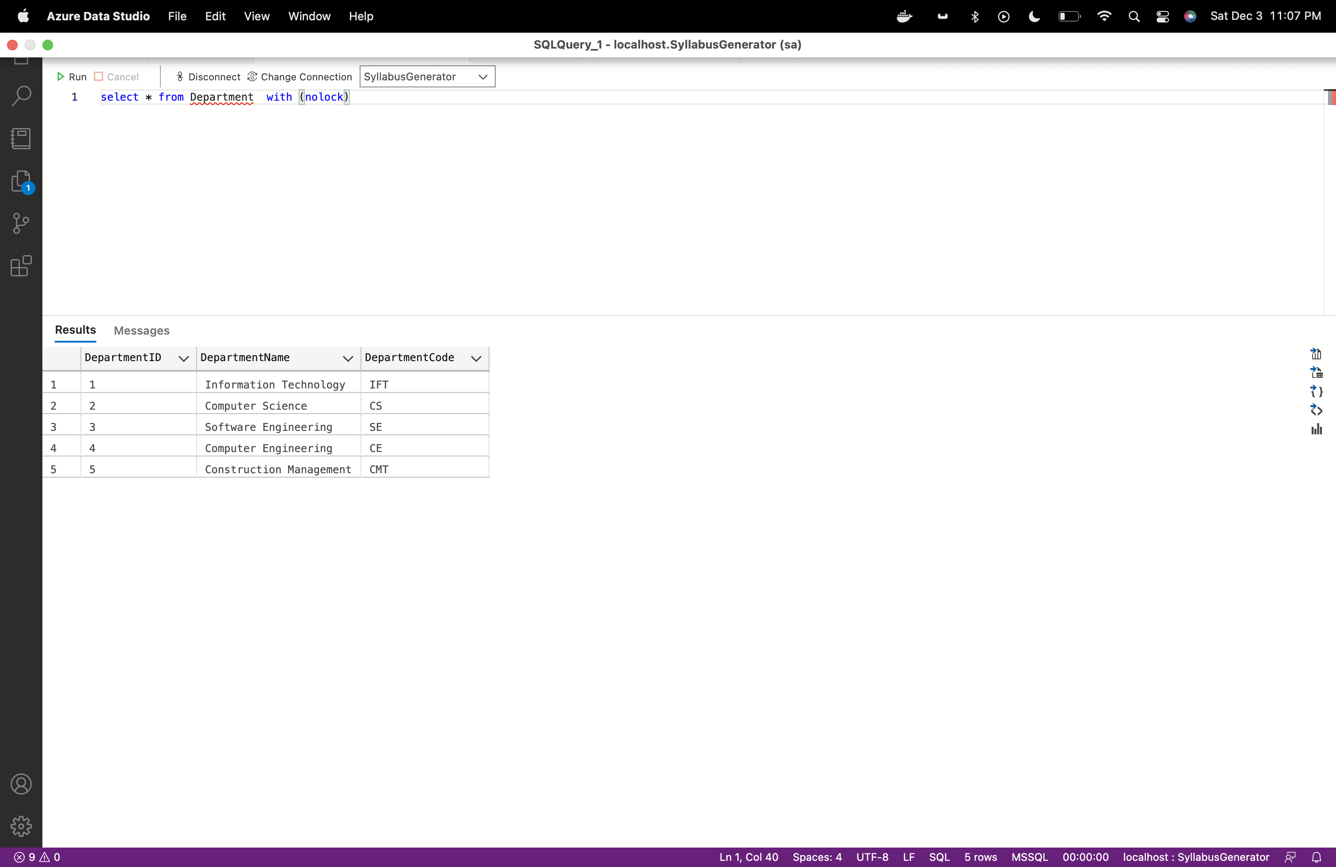

**ProgramChair:**

Query: select * from ProgramChair with (nolock)

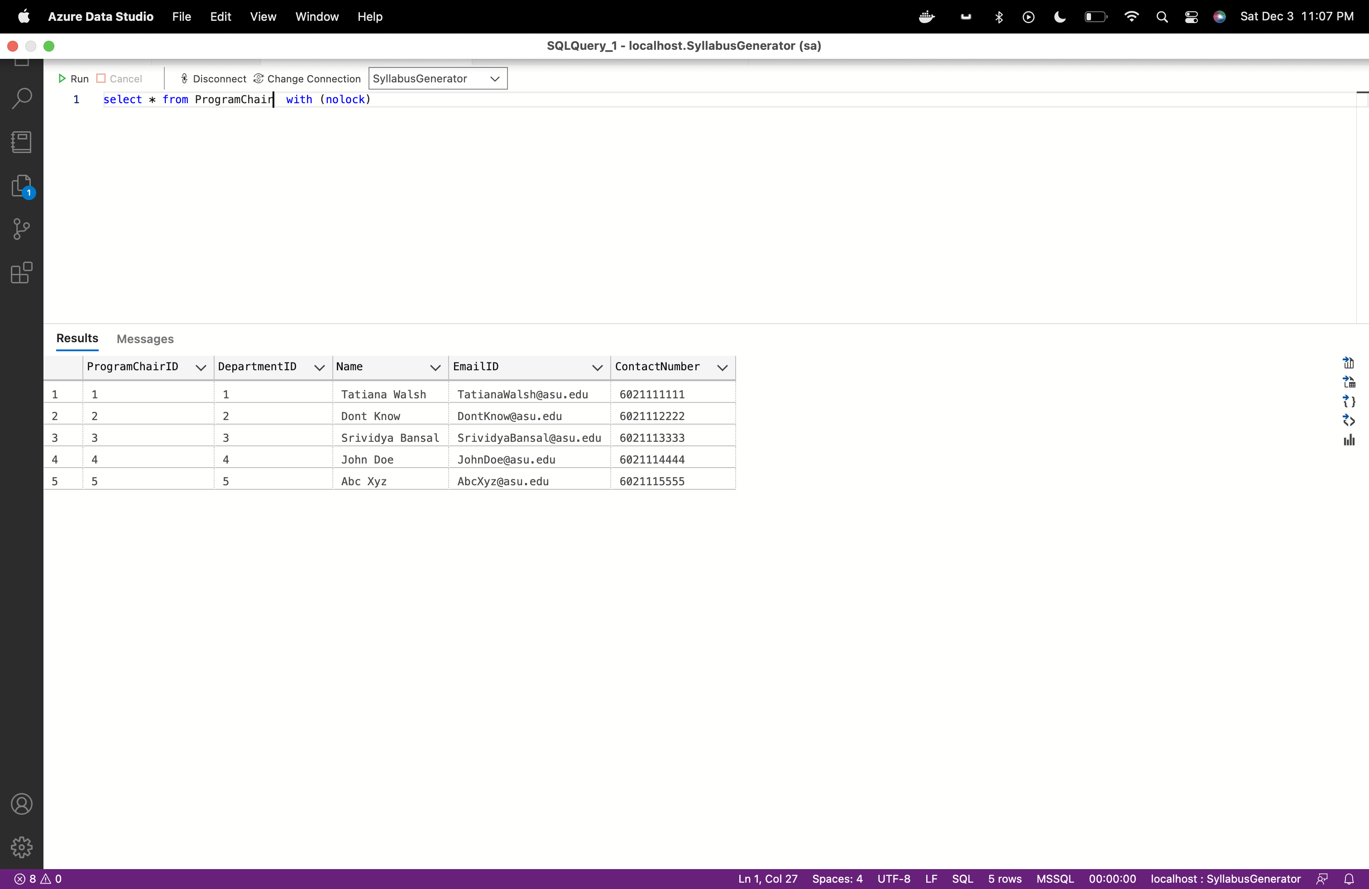

**Professor:**

Query: select * from Professor with (nolock)

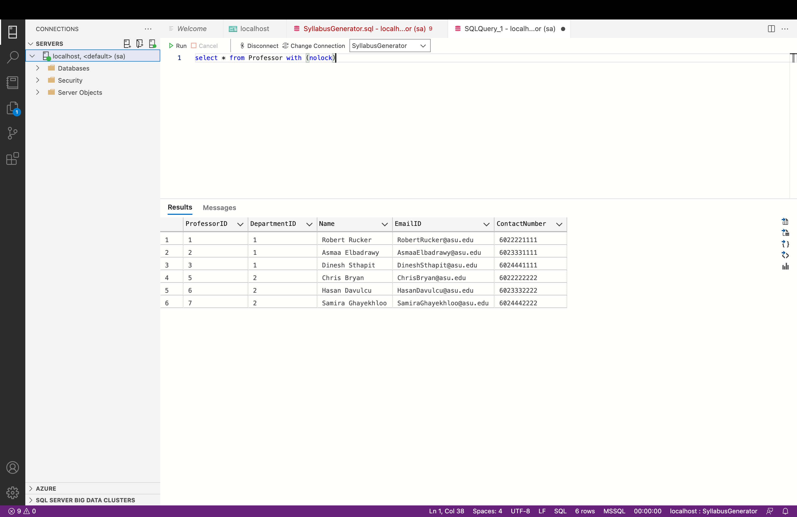

**Course:**

Query: select * from Course with (nolock)

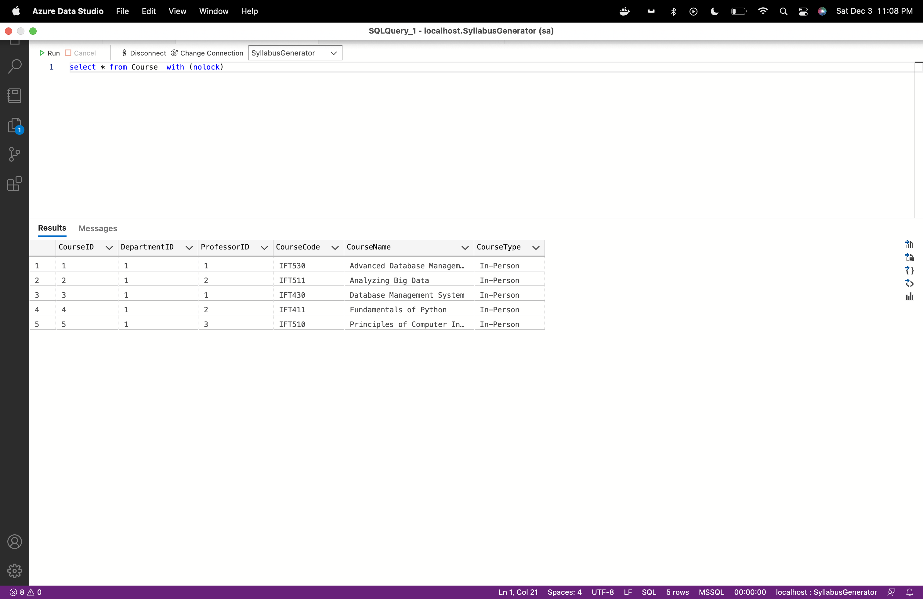

**Syllabus:**

Query: select * from Syllabus with (nolock)

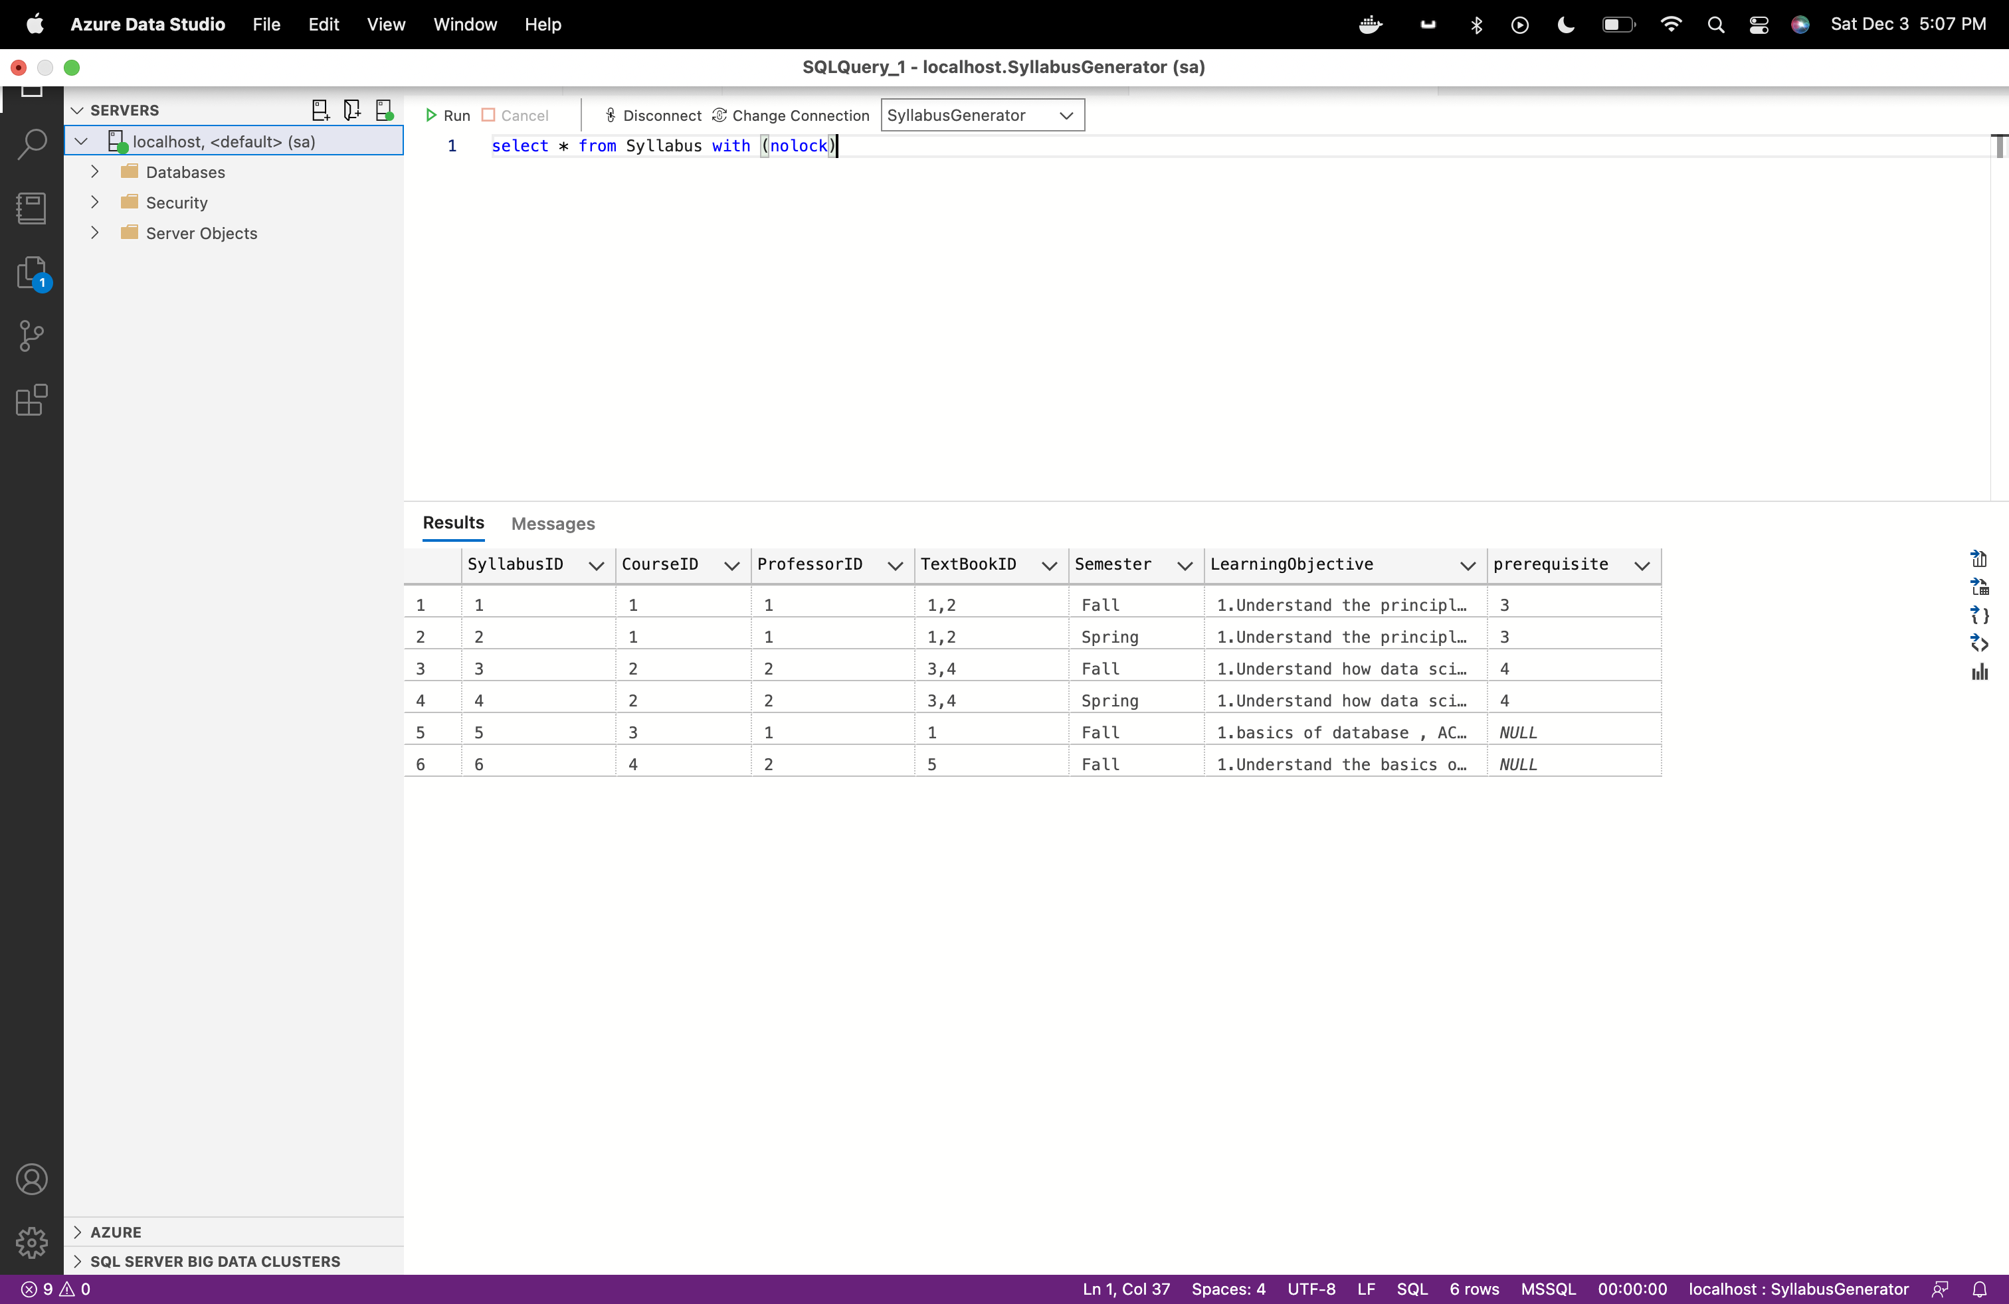

**CourseSchedule:**

Query: select * from CourseSchedule with (nolock)

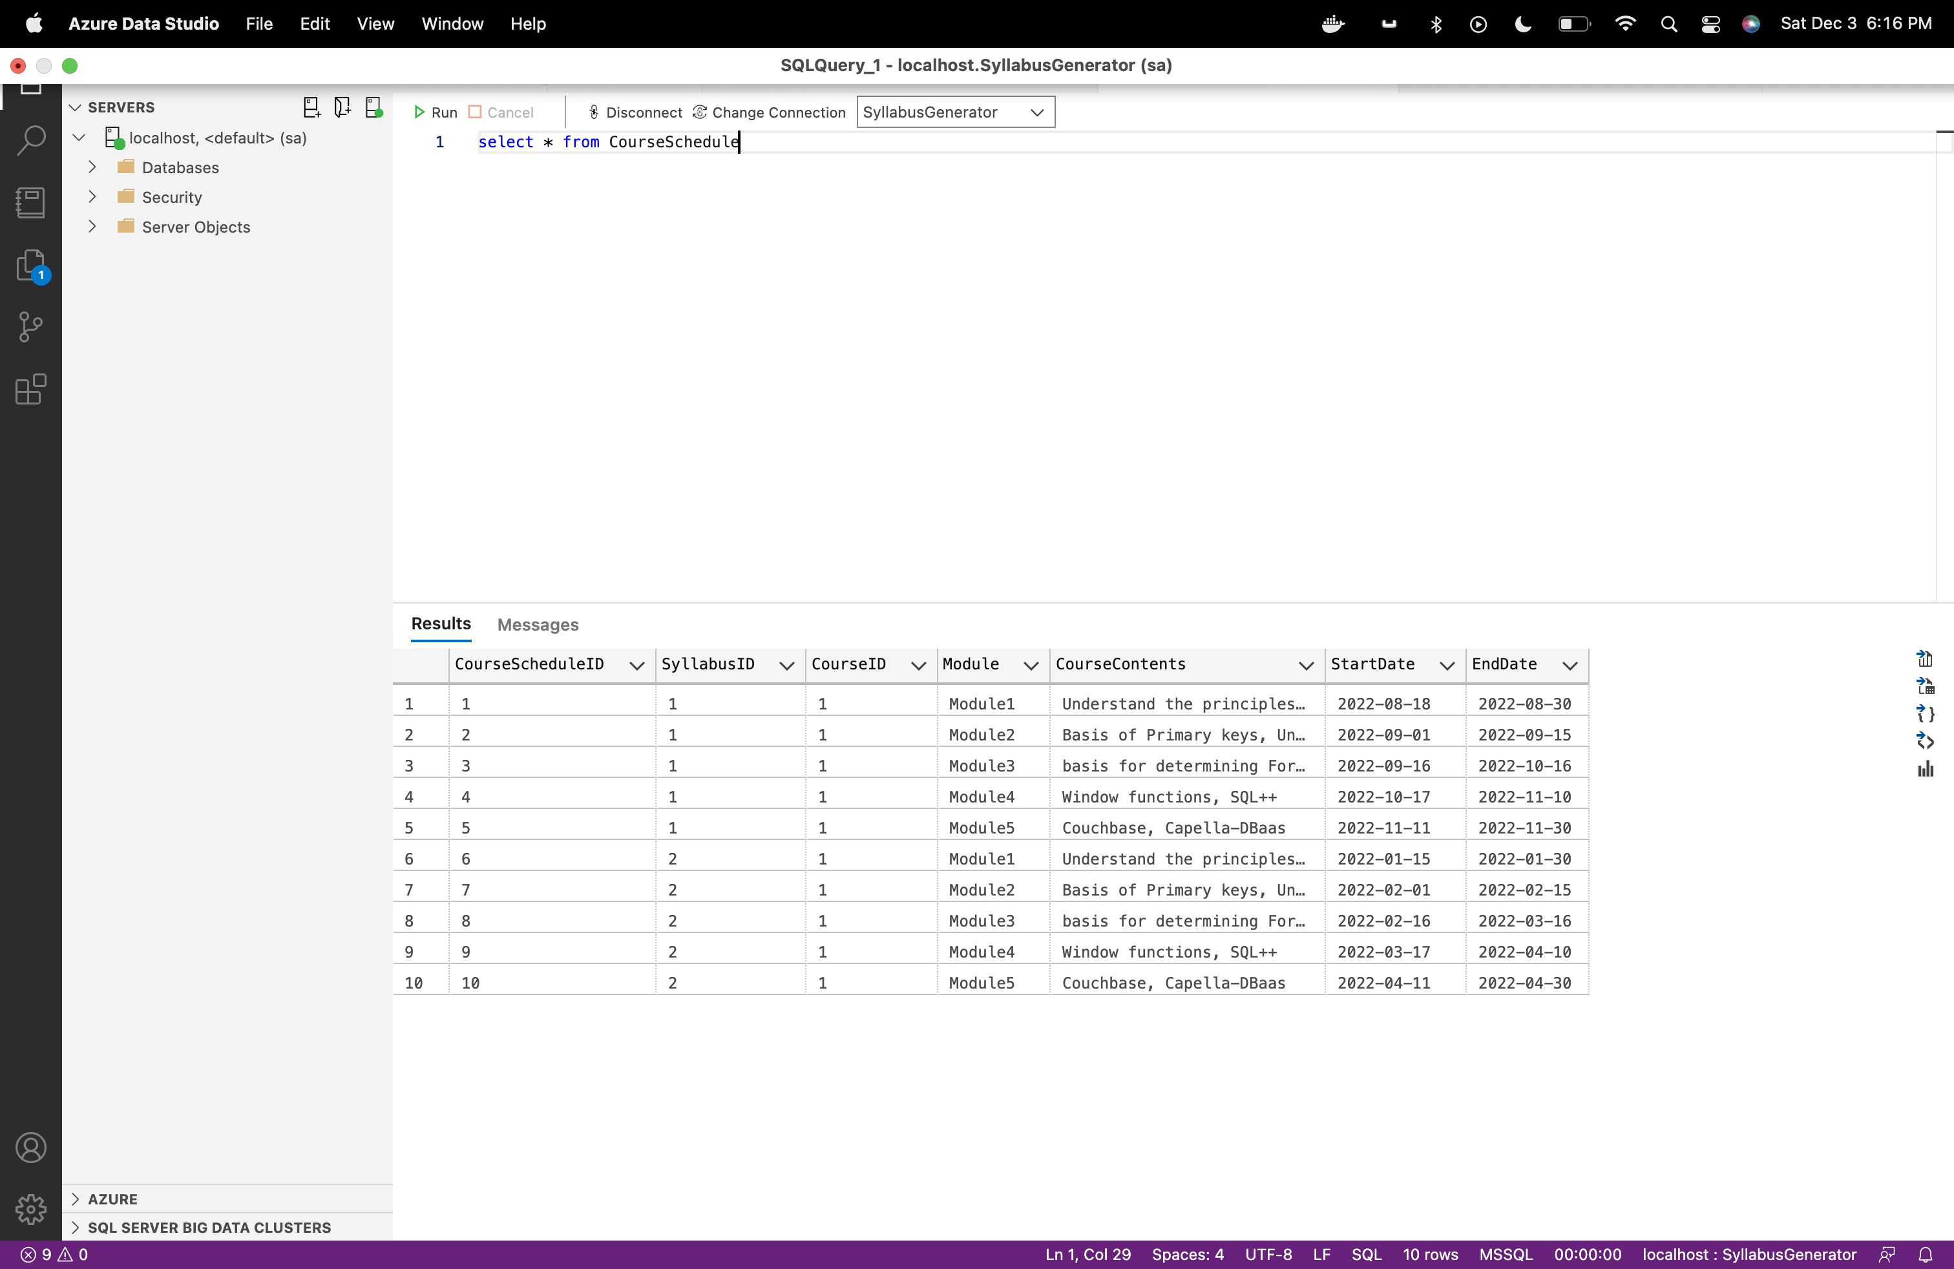

**Textbook:**

Query: select * from TextBook with (nolock)

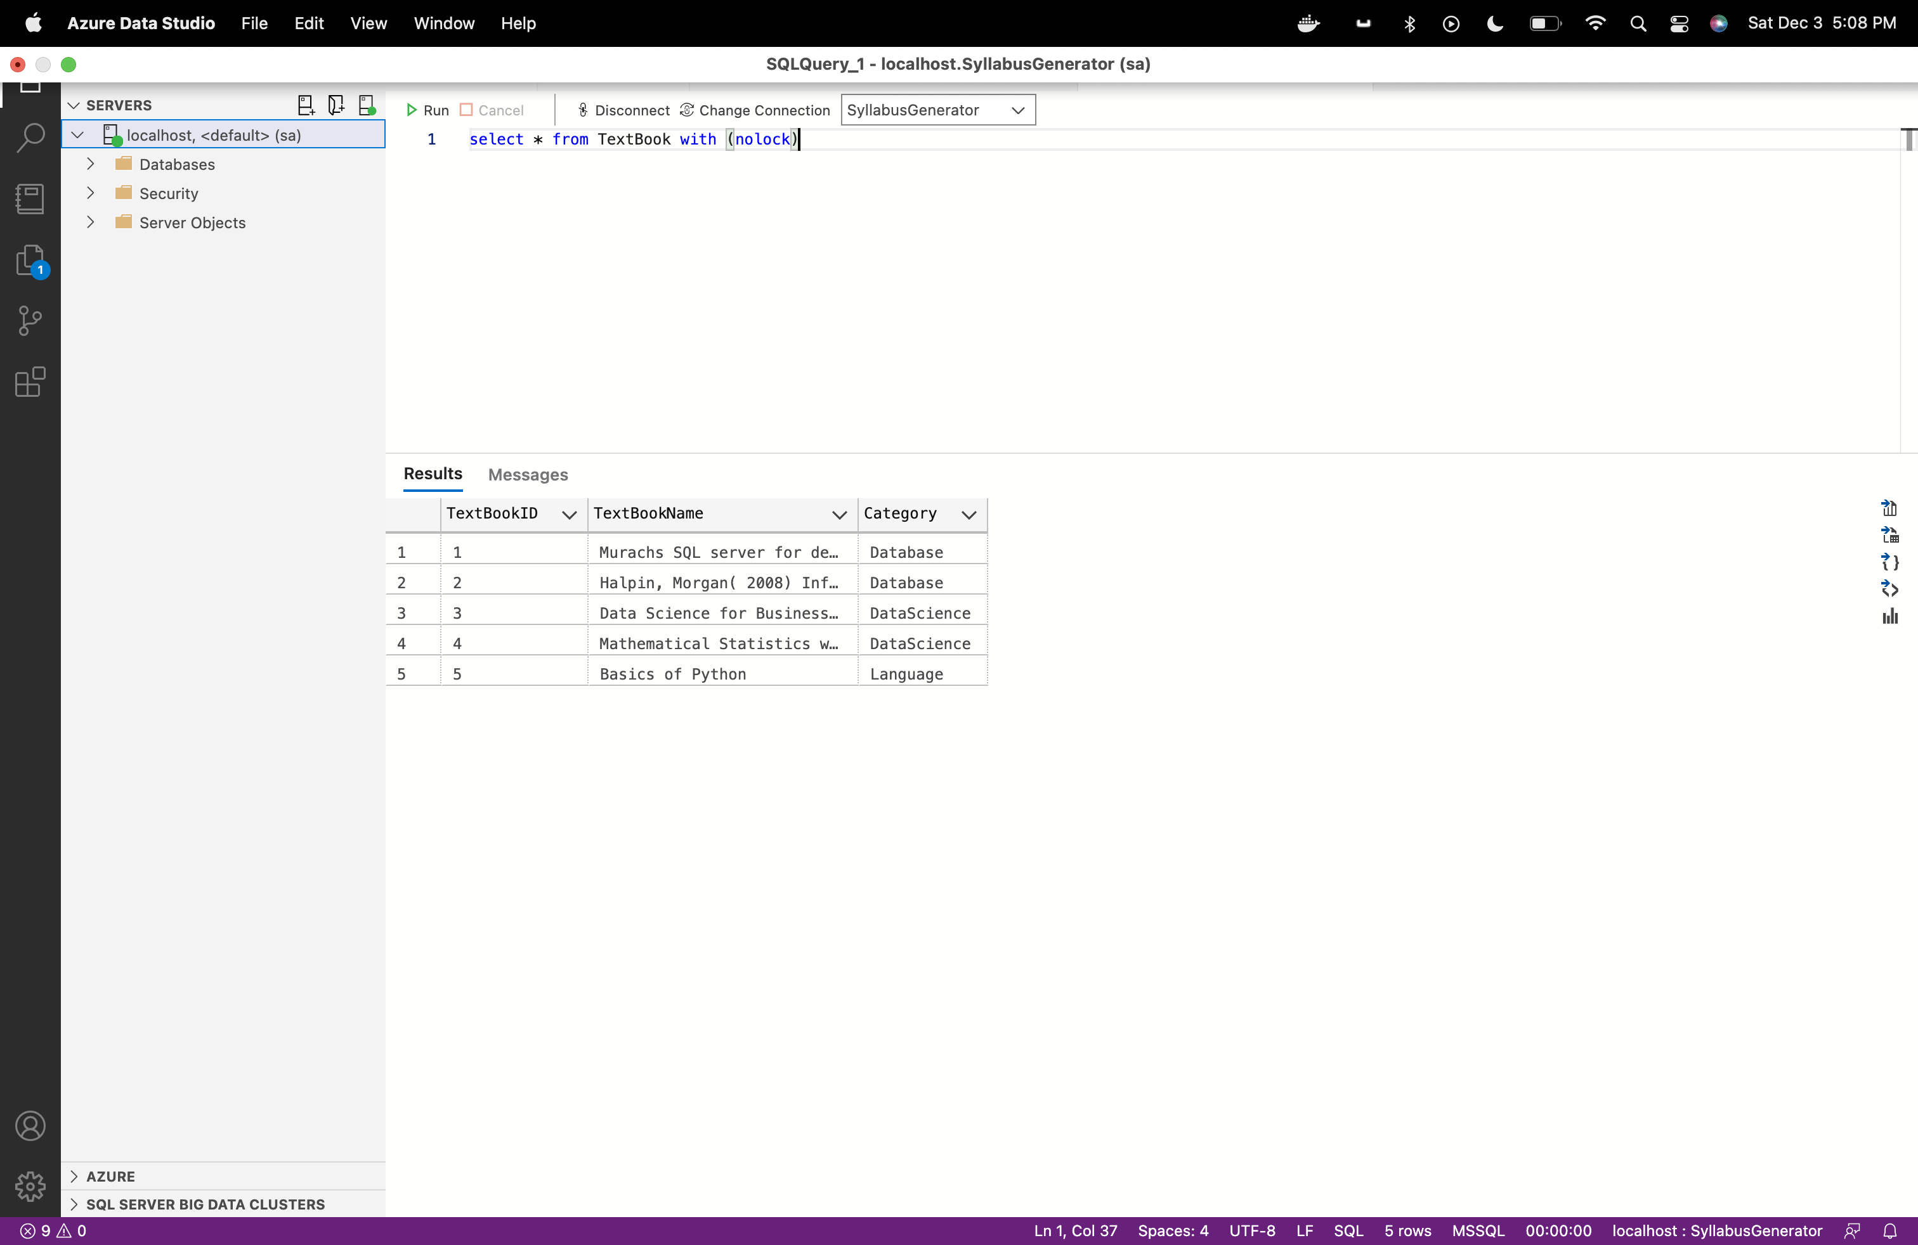

**Queries:**

1. **Current department details.**

SELECT DISTINCT d.DepartmentID

,DepartmentName

,DepartmentCode

,pc.Name AS Program_chair

,count(p.ProfessorID) OVER (PARTITION BY p.DepartmentID) AS Professor_count

FROM department d WITH (NOLOCK)

left OUTER JOIN professor p WITH (NOLOCK) ON d.DepartmentID = p.DepartmentID

INNER JOIN ProgramChair pc WITH (NOLOCK) ON d.DepartmentID = pc.DepartmentID

ORDER BY d.DepartmentID ASC

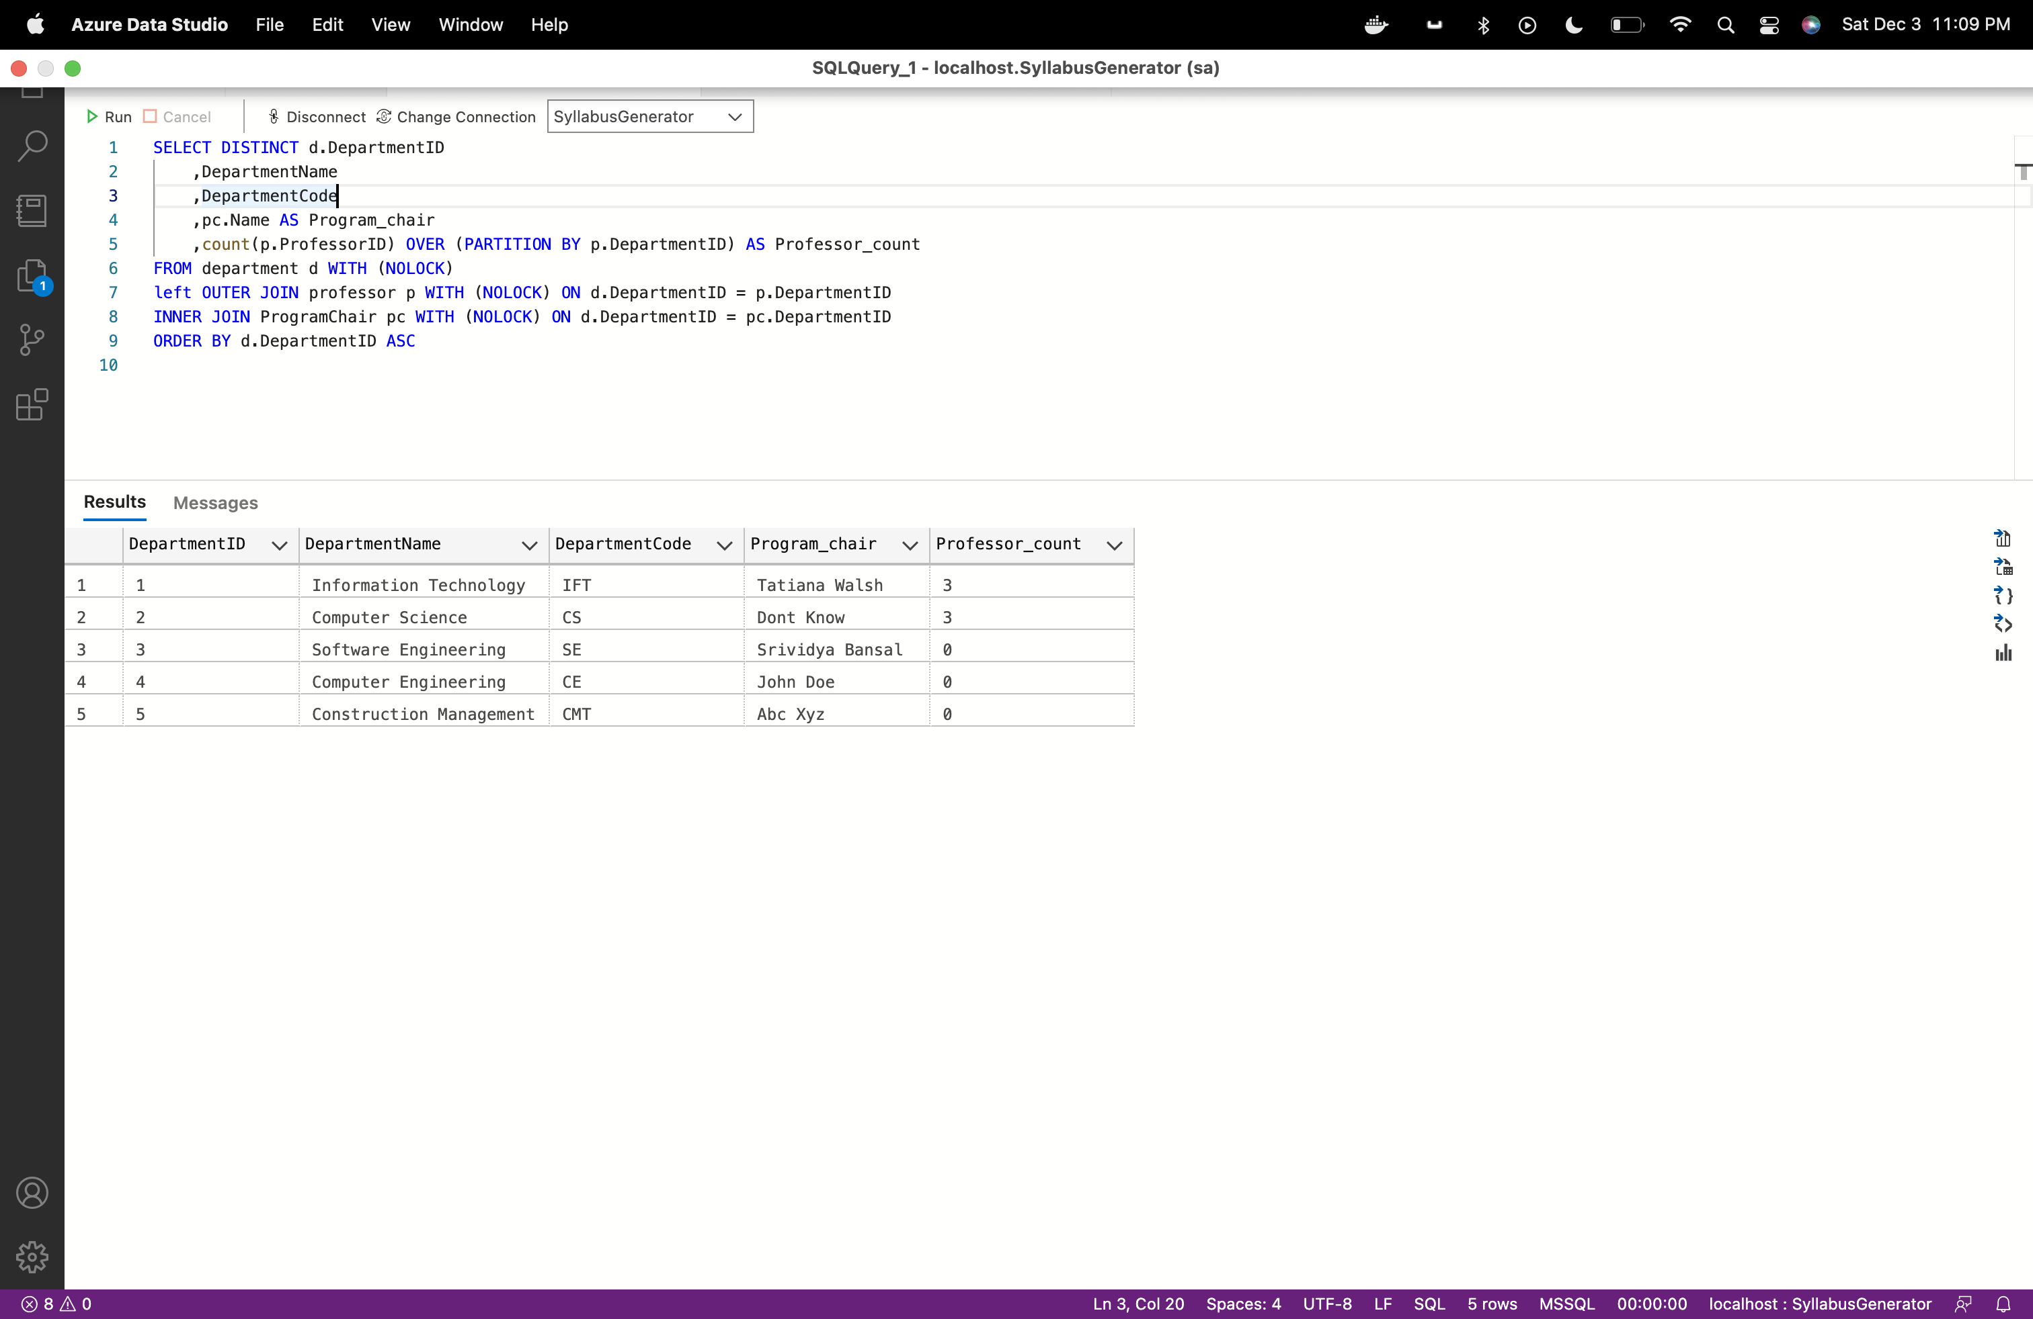

1. **Department wise programchair and professor details**

SELECT DISTINCT d.DepartmentID

,DepartmentName

,DepartmentCode

,pc.Name AS Program_chair

,count(p.ProfessorID) OVER (PARTITION BY p.DepartmentID) AS Total_Professor_count

,p.Name AS Professor

FROM department d WITH (NOLOCK)

left OUTER JOIN professor p WITH (NOLOCK) ON d.DepartmentID = p.DepartmentID

INNER JOIN ProgramChair pc WITH (NOLOCK) ON d.DepartmentID = pc.DepartmentID

ORDER BY d.DepartmentID ASC

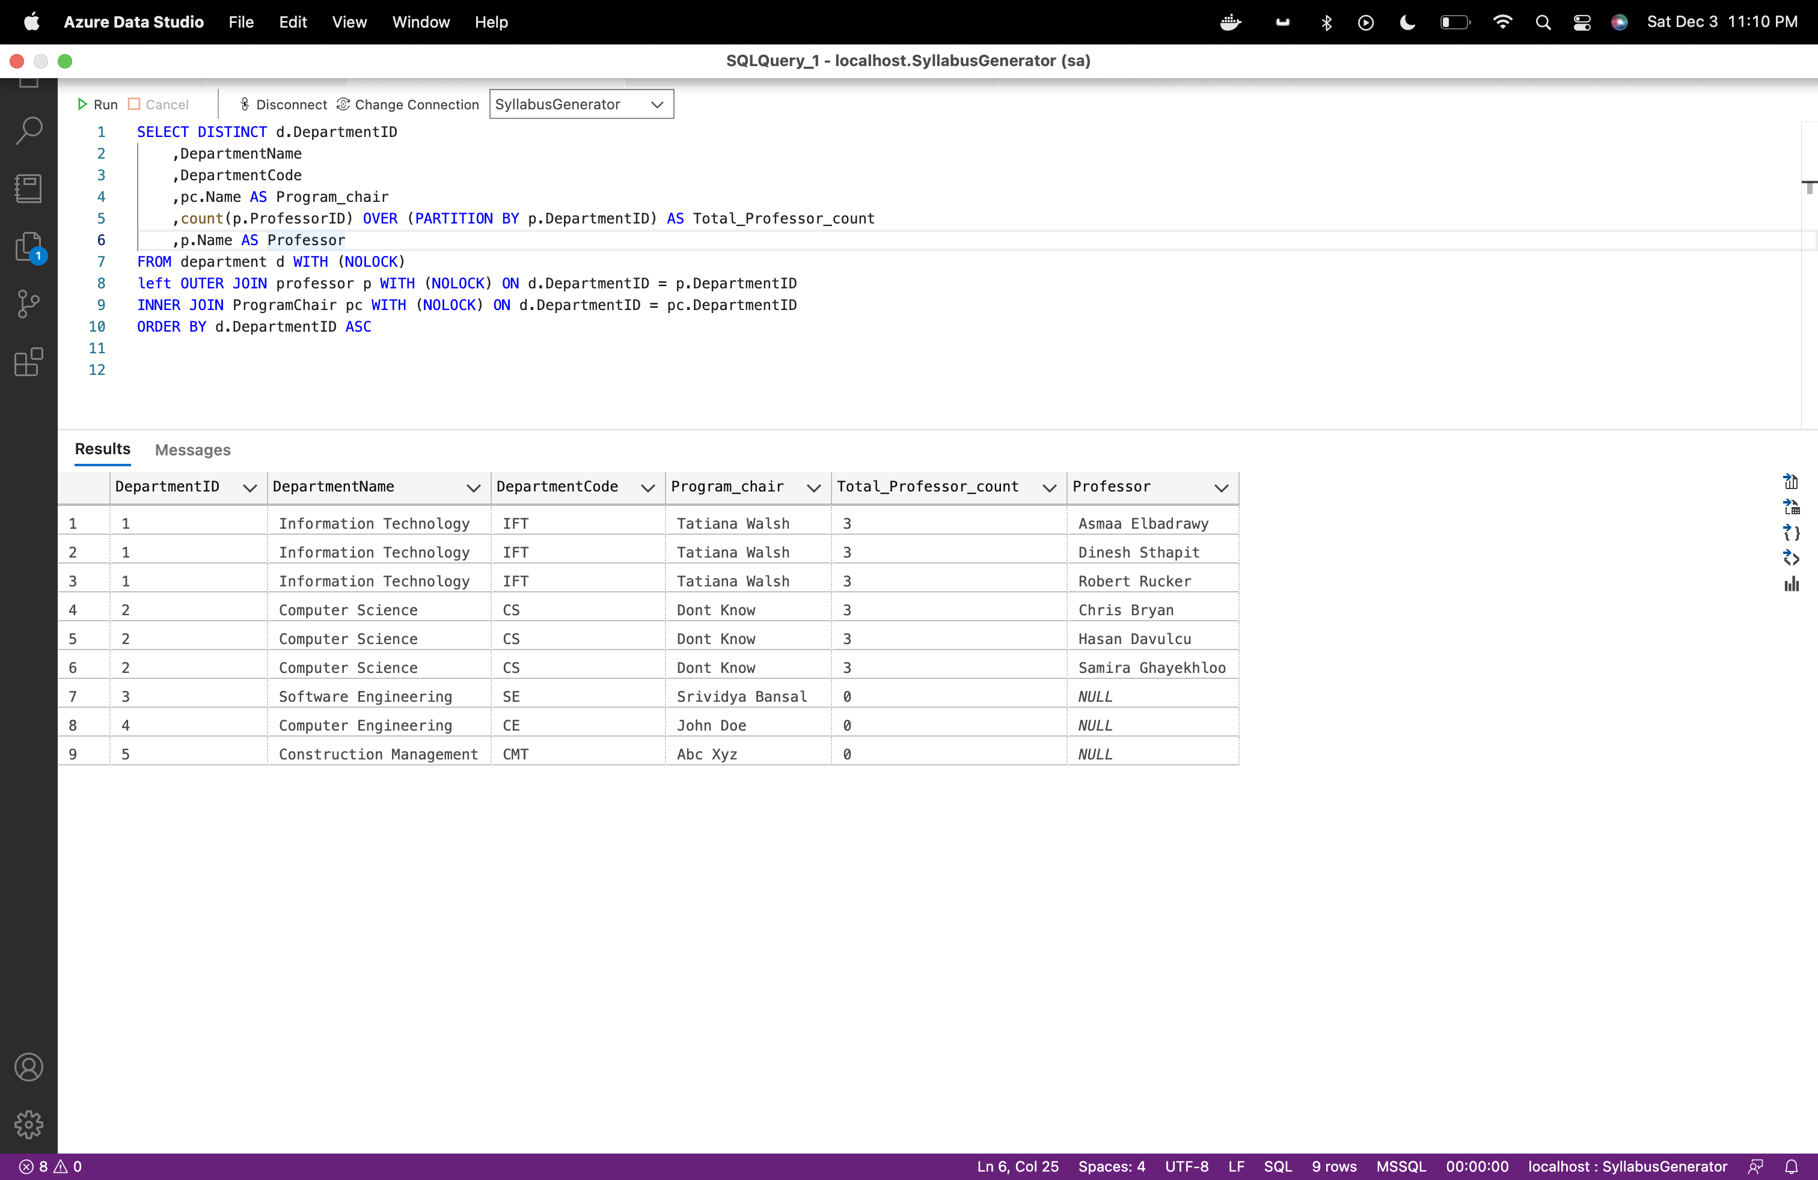

1. **Professor teaching particular course**

SELECT DISTINCT

p.ProfessorID

,p.Name AS professor

,count(c.CourseID) OVER (PARTITION BY p.ProfessorID) AS Total_Course_count

,c.CourseCode AS Course_Code

,c.CourseName AS Course_Name

,c.CourseType AS Course_Type

FROM Professor p WITH (NOLOCK)

left OUTER JOIN Course c WITH (NOLOCK) ON c.ProfessorID = p.ProfessorID

ORDER BY p.ProfessorID ASC

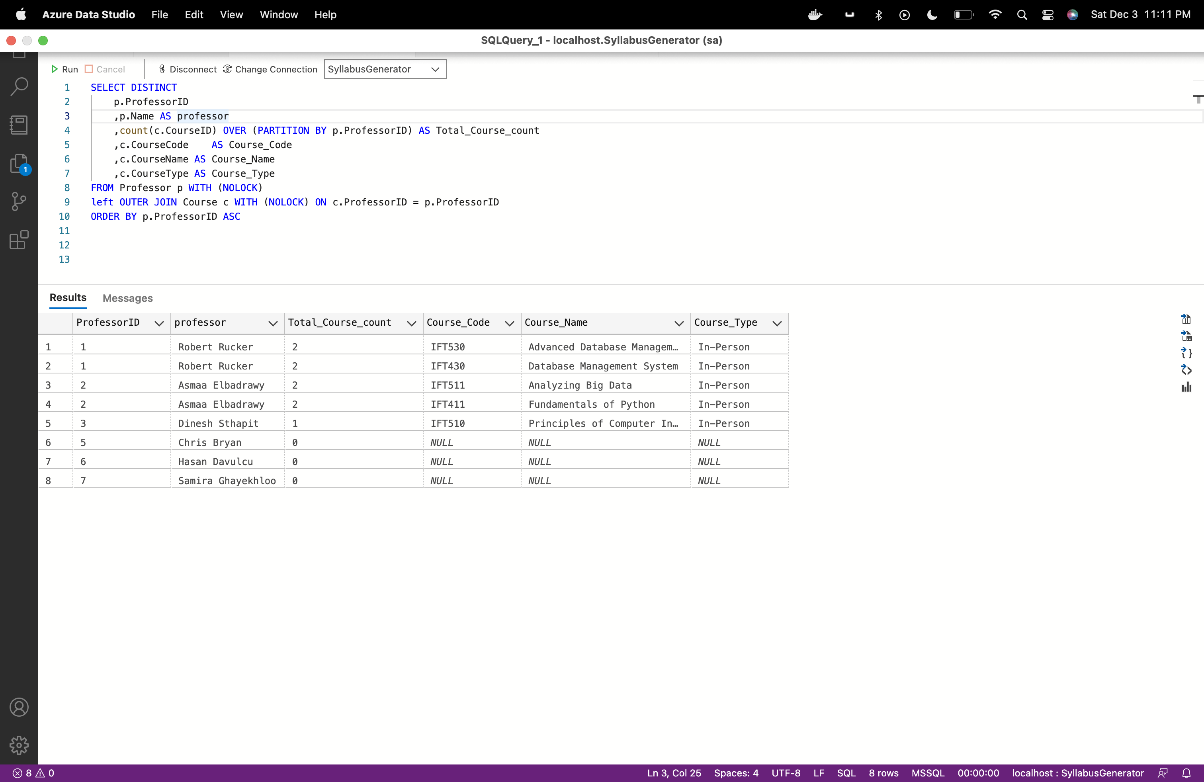

1. **Professor and Program chair contact details**

(SELECT

p.Name AS Name

,p.ContactNumber AS Contact

,p.EmailID AS Email

,'Professor' as Role

FROM Professor p WITH (NOLOCK)

UNION

SELECT

pc.Name AS Name

,pc.ContactNumber AS Contact

,pc.EmailID AS Email

,'ProgramChair' as Role

FROM ProgramChair pc WITH (NOLOCK))

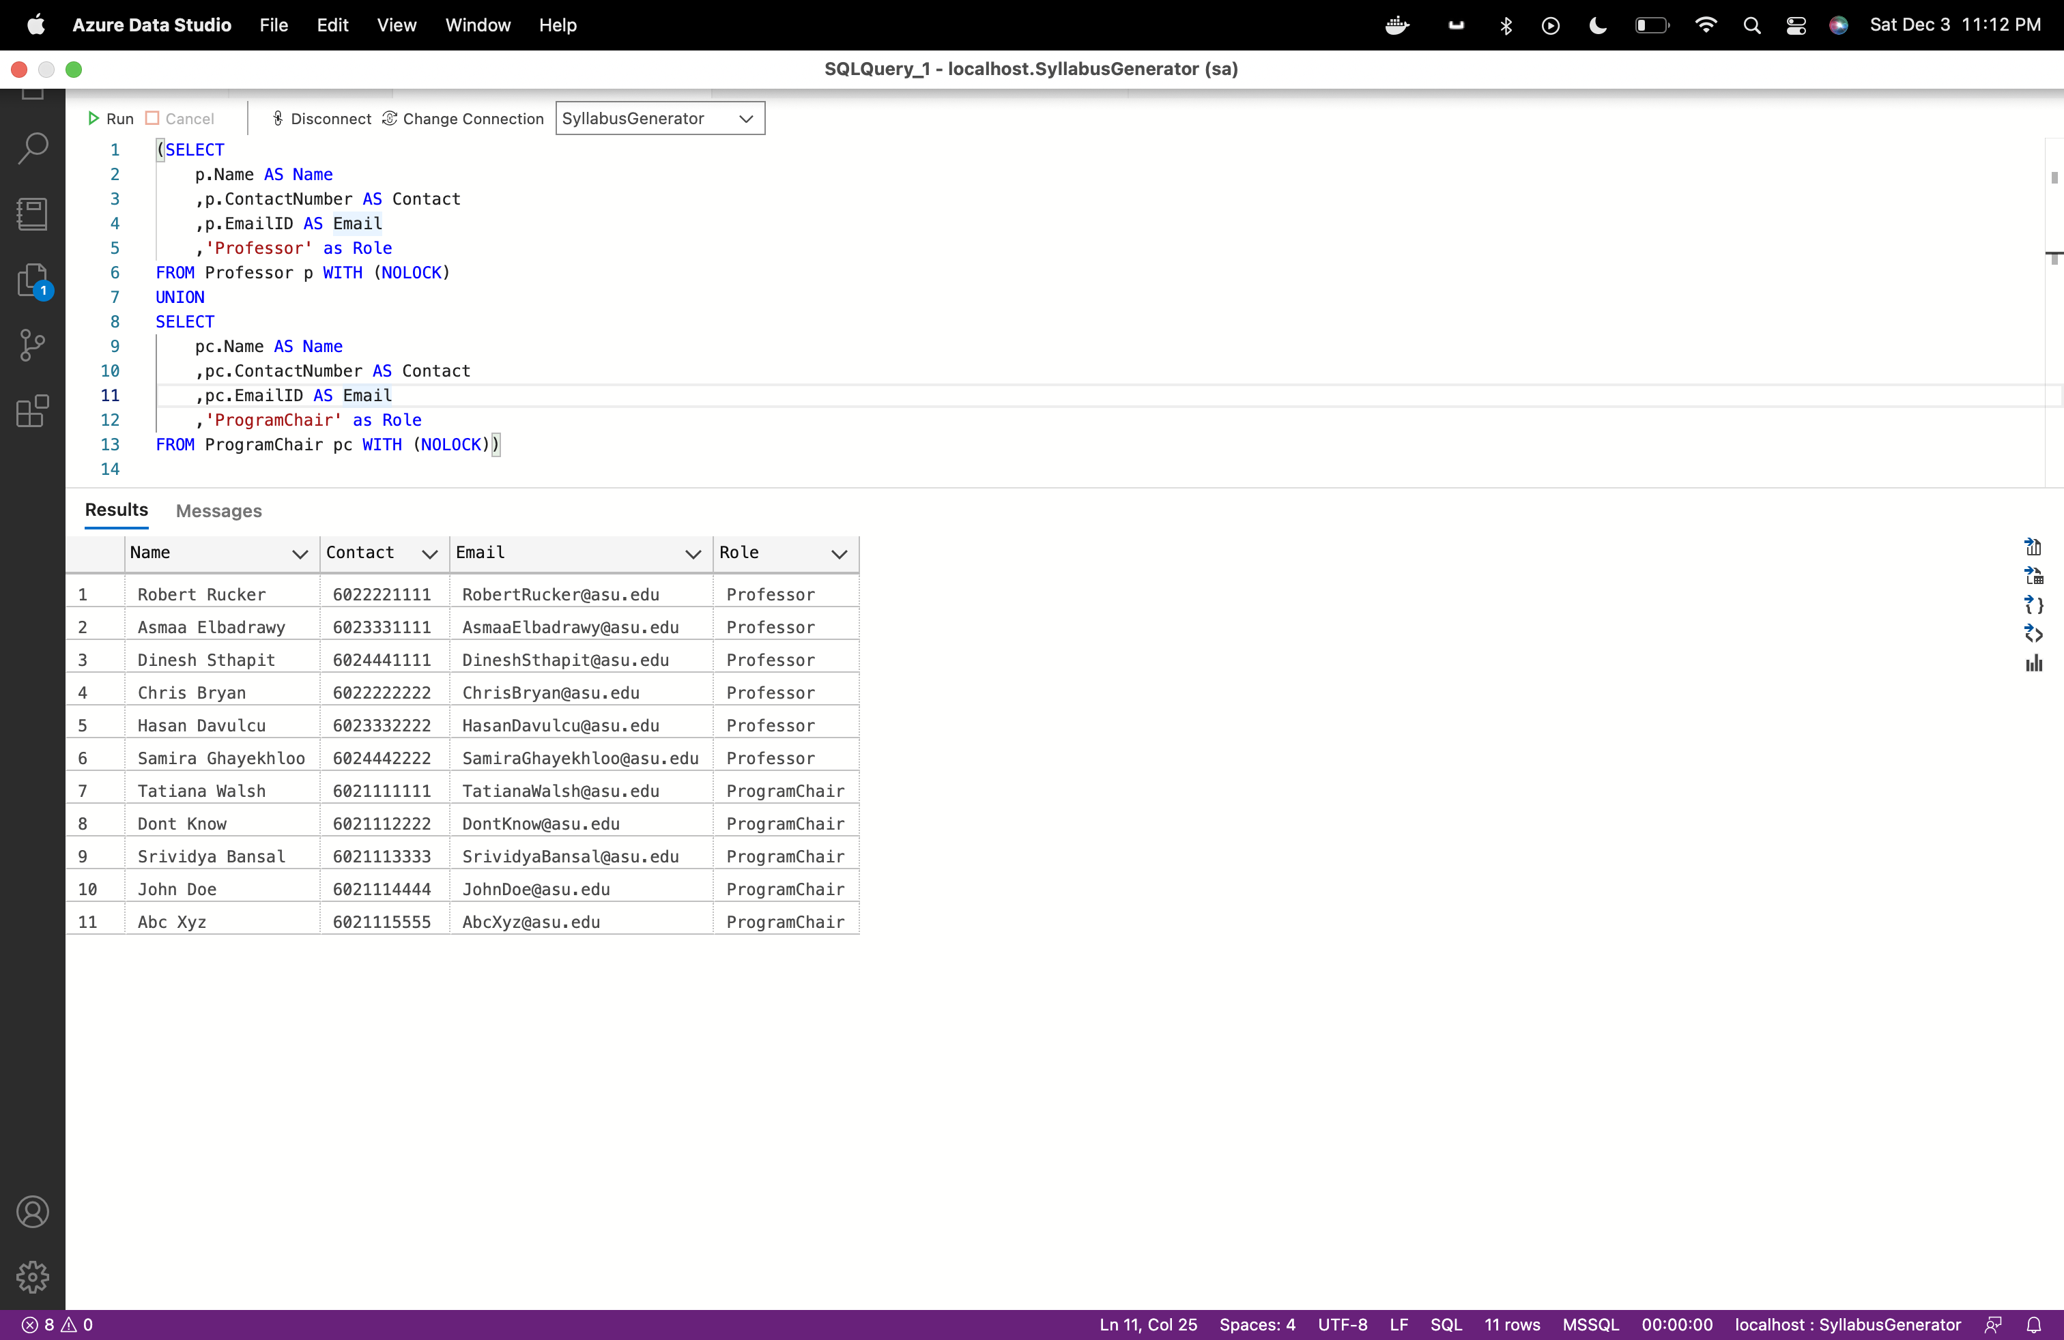

1. **Start and end date of syllabus**

SELECT DISTINCT

c.CourseName + '('+ s.Semester + ')' as CourseName

,min(cs.StartDate) over (PARTITION by cs.SyllabusID) as Course_start_date

,max(cs.EndDate) over (PARTITION by cs.SyllabusID) as Course_end_date

FROM Syllabus s WITH (NOLOCK)

INNER JOIN Course c WITH (NOLOCK) ON c.CourseID = s.CourseID

INNER JOIN CourseSchedule cs WITH (NOLOCK) ON cs.SyllabusID = s.SyllabusID

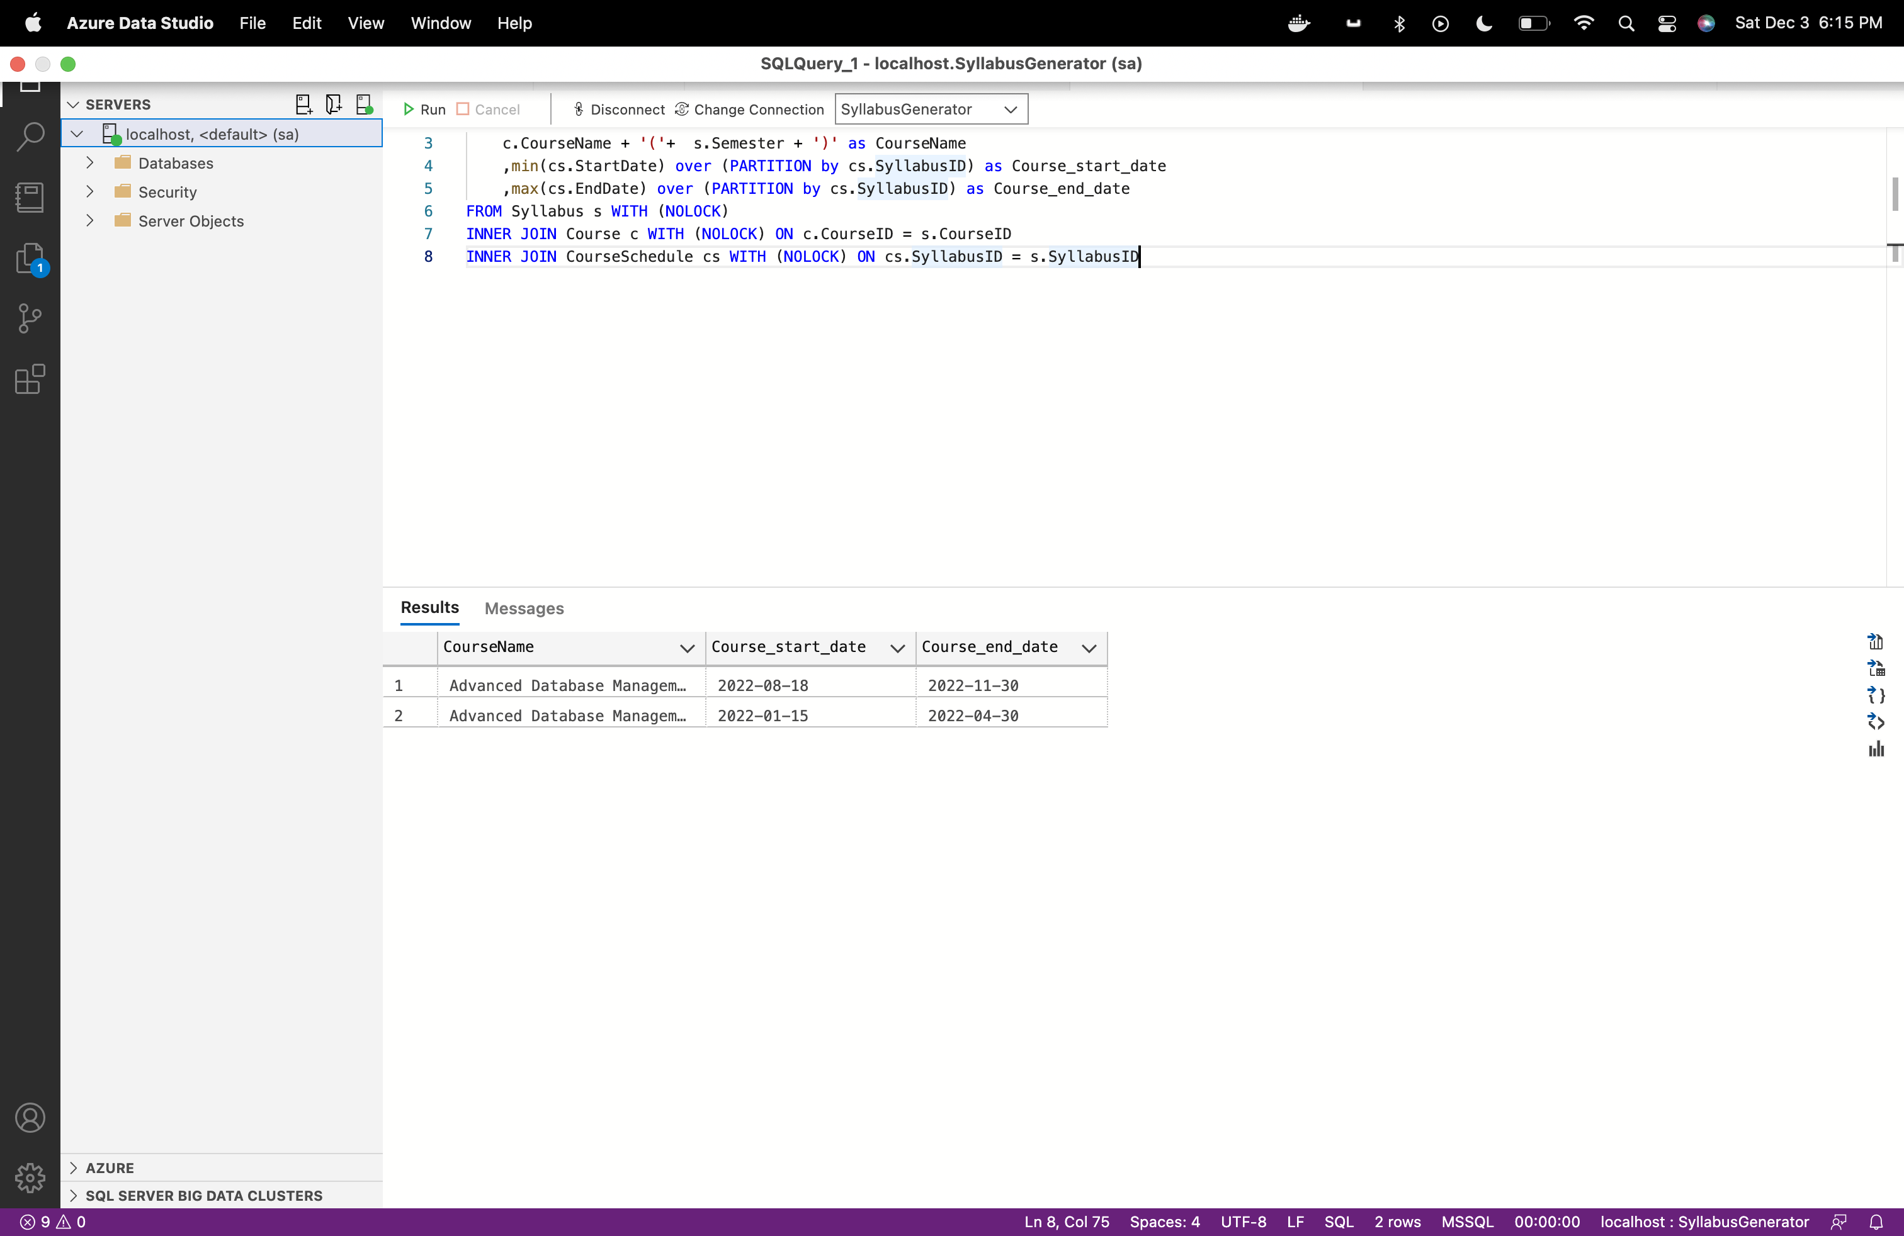

1. **Course wise textbook list.**

SELECT DISTINCT

s.SyllabusID

,c.CourseName + '('+ s.Semester + ')' as CourseName

,t.TextBookName

FROM Syllabus s WITH (NOLOCK)

INNER JOIN Course c WITH (NOLOCK) ON c.CourseID = s.CourseID

,TextBook t WITH (NOLOCK)

where t.TextBookID in (select * from STRING_SPLIT((select TextBookID from Syllabus where SyllabusID = s.SyllabusID), ','))

order by s.SyllabusID asc

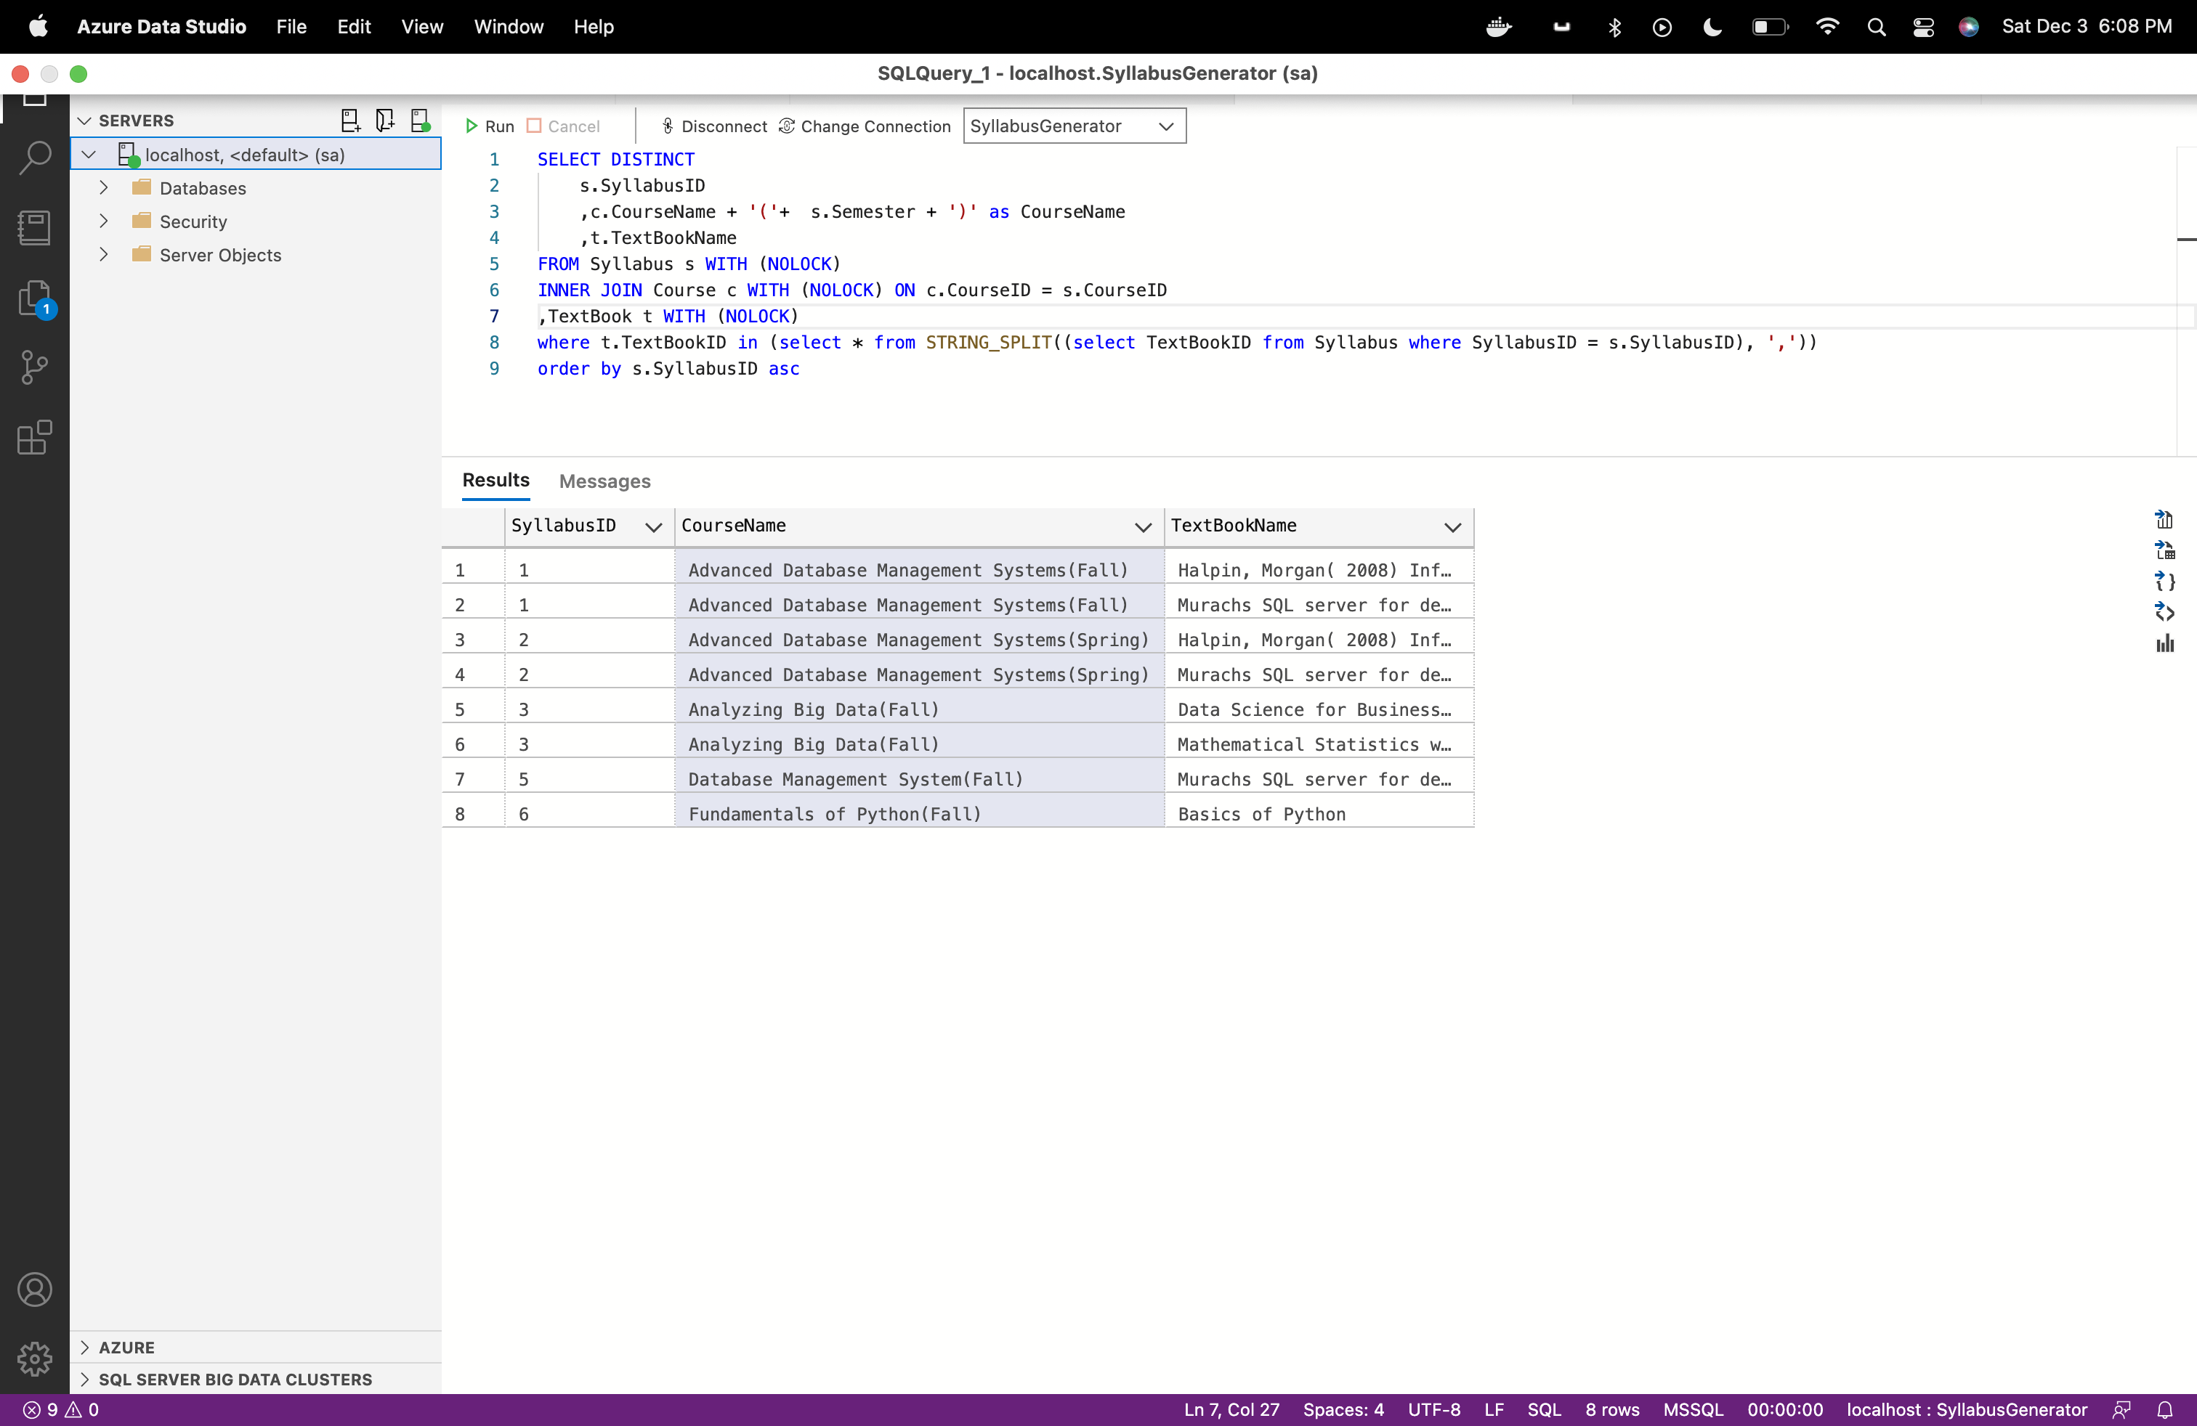

**Stored Procedure:**

**1.Stored procedure to fetch all courses of professor:**

Query:

use SyllabusGenerator

GO

IF EXISTS (SELECT * FROM sys.objects WHERE type = 'P' AND OBJECT_ID = OBJECT_ID('dbo.spFetchCourses'))

drop proc spFetchCourses

GO

Create proc spFetchCourses

@ProfessorID Int

AS

BEGIN

Select c.CourseCode as CourseCode

, c.CourseName + '('+ ss.Semester + ')' as CourseName

, c.CourseType as CourseType

, c.CourseID as CourseID

, d.DepartmentName as DepartmentName

, d.DepartmentCode as DepartmentCode

, d.DepartmentID as DepartmentID

, ss.SyllabusID

from SyllabusGenerator..course c with (nolock) inner join SyllabusGenerator..Syllabus ss with (nolock) on c.CourseID = ss.CourseID

inner join SyllabusGenerator..Department d with (nolock) on d.DepartmentID = c.DepartmentID

where c.ProfessorID = @ProfessorID

END

exec spFetchCourses 1

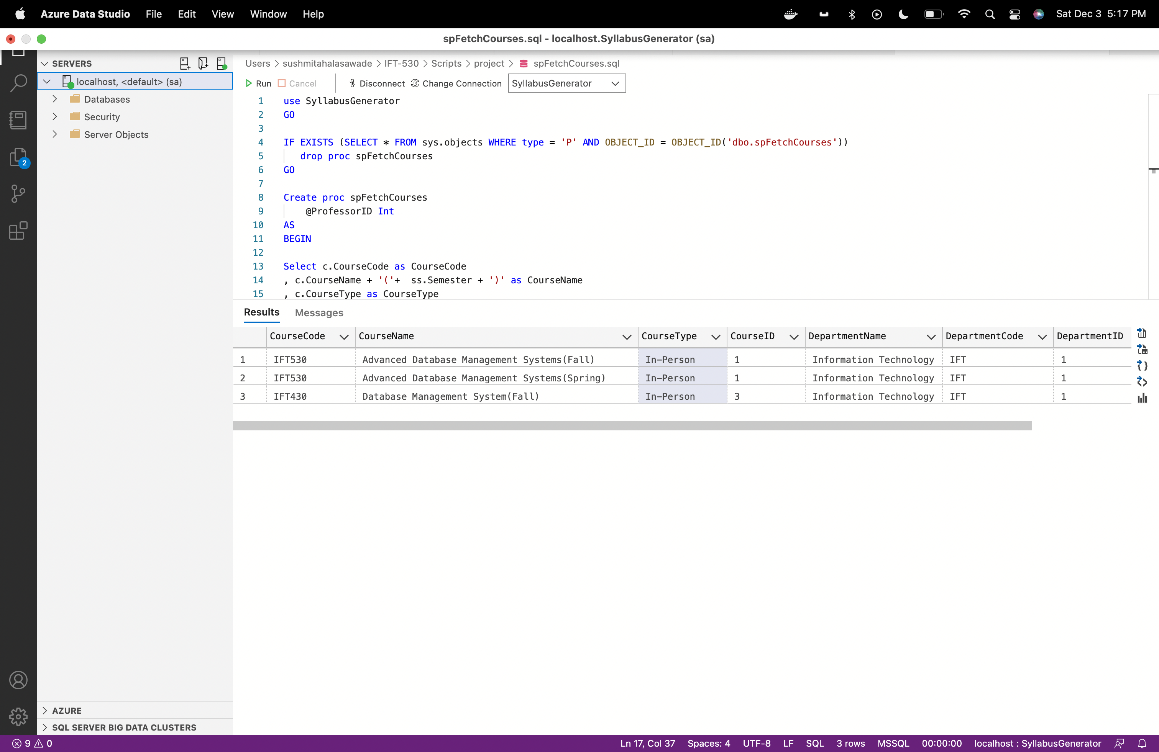

**2.Stored procedure to fetch Syllabus details of course taught by professor:**

Query:

use SyllabusGenerator

GO

IF EXISTS (SELECT * FROM sys.objects WHERE type = 'P' AND OBJECT_ID = OBJECT_ID('dbo.spFetchSyllabusDetails'))

drop proc spFetchSyllabusDetails

GO

Create proc spFetchSyllabusDetails

@ProfessorID Int ,

@SyllabusID Int

AS

BEGIN

Select c.CourseName + '('+ ss.Semester + ')' as CourseName,ss.LearningObjective,ss.TextBookID,ss.prerequisite,cs.[Module],cs.CourseContents,cs.StartDate,cs.EndDate

from SyllabusGenerator..syllabus ss with (nolock) inner join SyllabusGenerator..CourseSchedule cs with (nolock) on ss.SyllabusID = cs.SyllabusID

inner join SyllabusGenerator..course c with (nolock) on c.CourseID = ss.CourseID

where ss.SyllabusID = @SyllabusID and ss.ProfessorID = @ProfessorID

END

--

--exec spFetchSyllabusDetails 1, 1

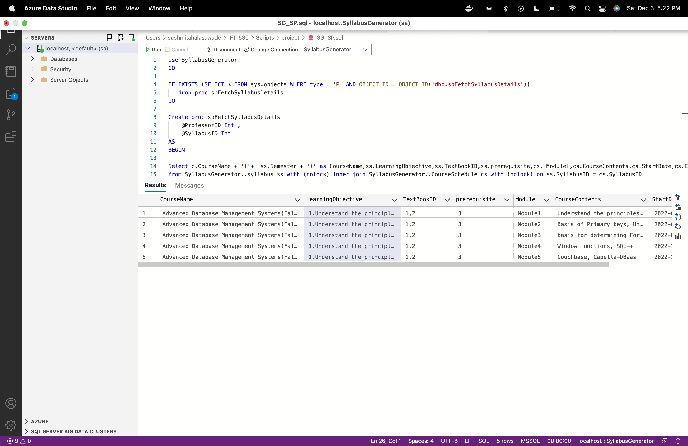

**3. Stored Procedure to insert or update the syllabus.**

Query:

use SyllabusGenerator

GO

IF EXISTS (SELECT * FROM sys.objects WHERE type = 'P' AND OBJECT_ID = OBJECT_ID('dbo.spInsertorUpdateSyllabus'))

drop proc spInsertorUpdateSyllabus

GO

Create proc spInsertorUpdateSyllabus

@SyllabusID varchar(10),

@textbookid varchar(100),

@LearningObjective varchar(max),

@prerequisite varchar(100),

@Module varchar(20),

@CourseContents varchar(max),

@StartDate DATE,

@EndDate DATE

AS

BEGIN

update Syllabus with (rowlock) set textbookid = @textbookid, LearningObjective= @LearningObjective, prerequisite= @prerequisite where SyllabusID = @SyllabusID

if Exists(select * from CourseSchedule where SyllabusID = @SyllabusID and module = @Module)

BEGIN

update CourseSchedule with (rowlock) set CourseContents = @CourseContents, StartDate= @StartDate, EndDate= @EndDate where SyllabusID = @SyllabusID and module = @Module

END

ELSE

BEGIN

INSERT INTO CourseSchedule ( SyllabusID, CourseID,Module,CourseContents,StartDate, EndDate) VALUES

( @SyllabusID, 1,@Module,@CourseContents, @StartDate,@EndDate)

END

END

Test:

--exec spInsertorUpdateSyllabus 1, '1,2', '1.Understand the principles of conceptual modeling,2.understand the use of scripts when implementing SQL code','3','Module1','Understand the principles of conceptual modeling(ORM).','18 Aug 2022','30 Aug 2022'

select CourseContents,StartDate,* from CourseSchedule where SyllabusID =1 and module = 'Module1'

This will update existing module content and start date.

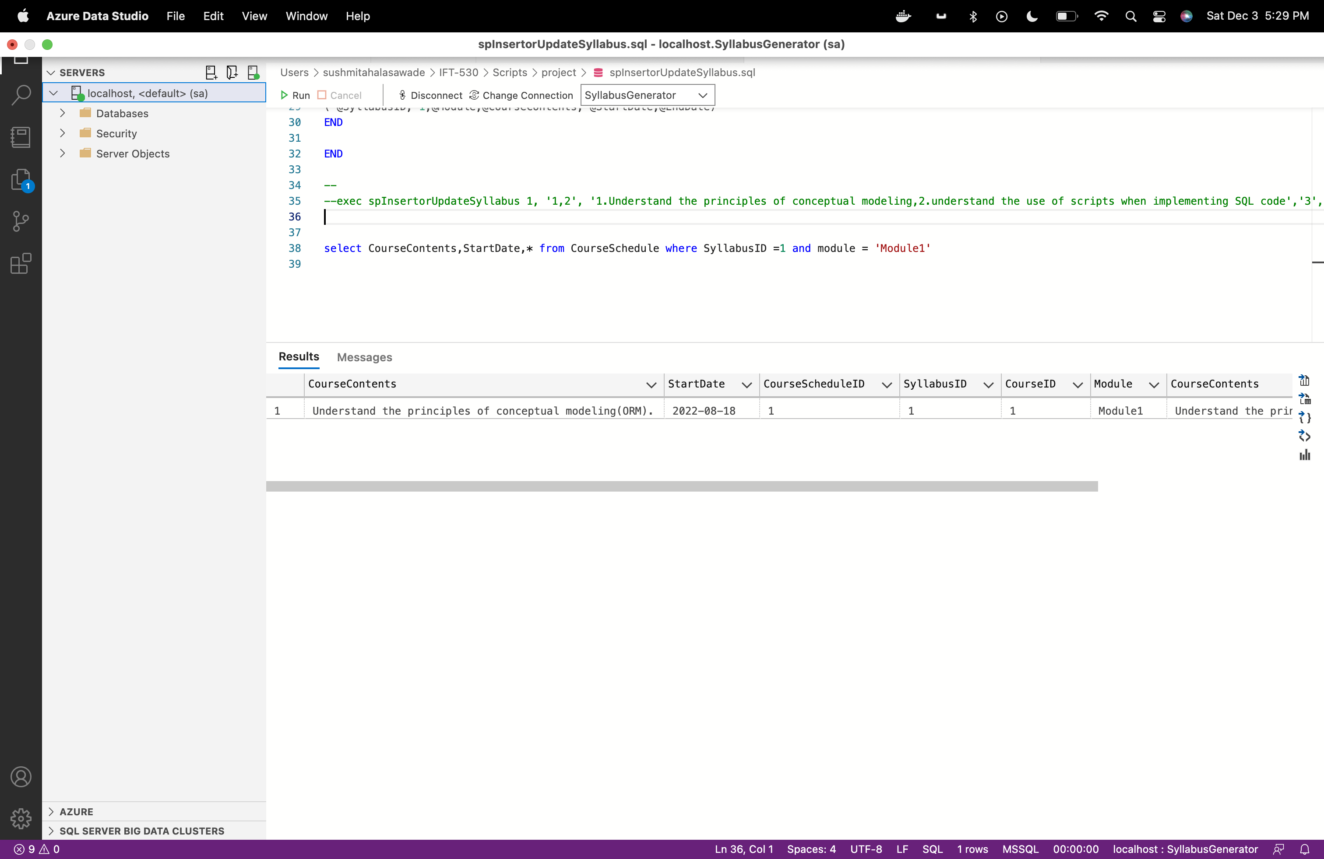

**4. Stored Procedure to delete complete syllabus.**

use SyllabusGenerator

GO

IF EXISTS (SELECT * FROM sys.objects WHERE type = 'P' AND OBJECT_ID = OBJECT_ID('dbo.spDeleteSyllabus'))

drop proc spDeleteSyllabus

GO

Create proc spDeleteSyllabus

@SyllabusID Int

AS

BEGIN

if exists(select * from SyllabusGenerator..CourseSchedule where SyllabusID = @SyllabusID)

begin

delete from SyllabusGenerator..CourseSchedule where SyllabusID = @SyllabusID

end

delete from SyllabusGenerator..Syllabus where SyllabusID = @SyllabusID

END

Test:

--exec spDeleteSyllabus 4

select * from Syllabus where SyllabusID = 4

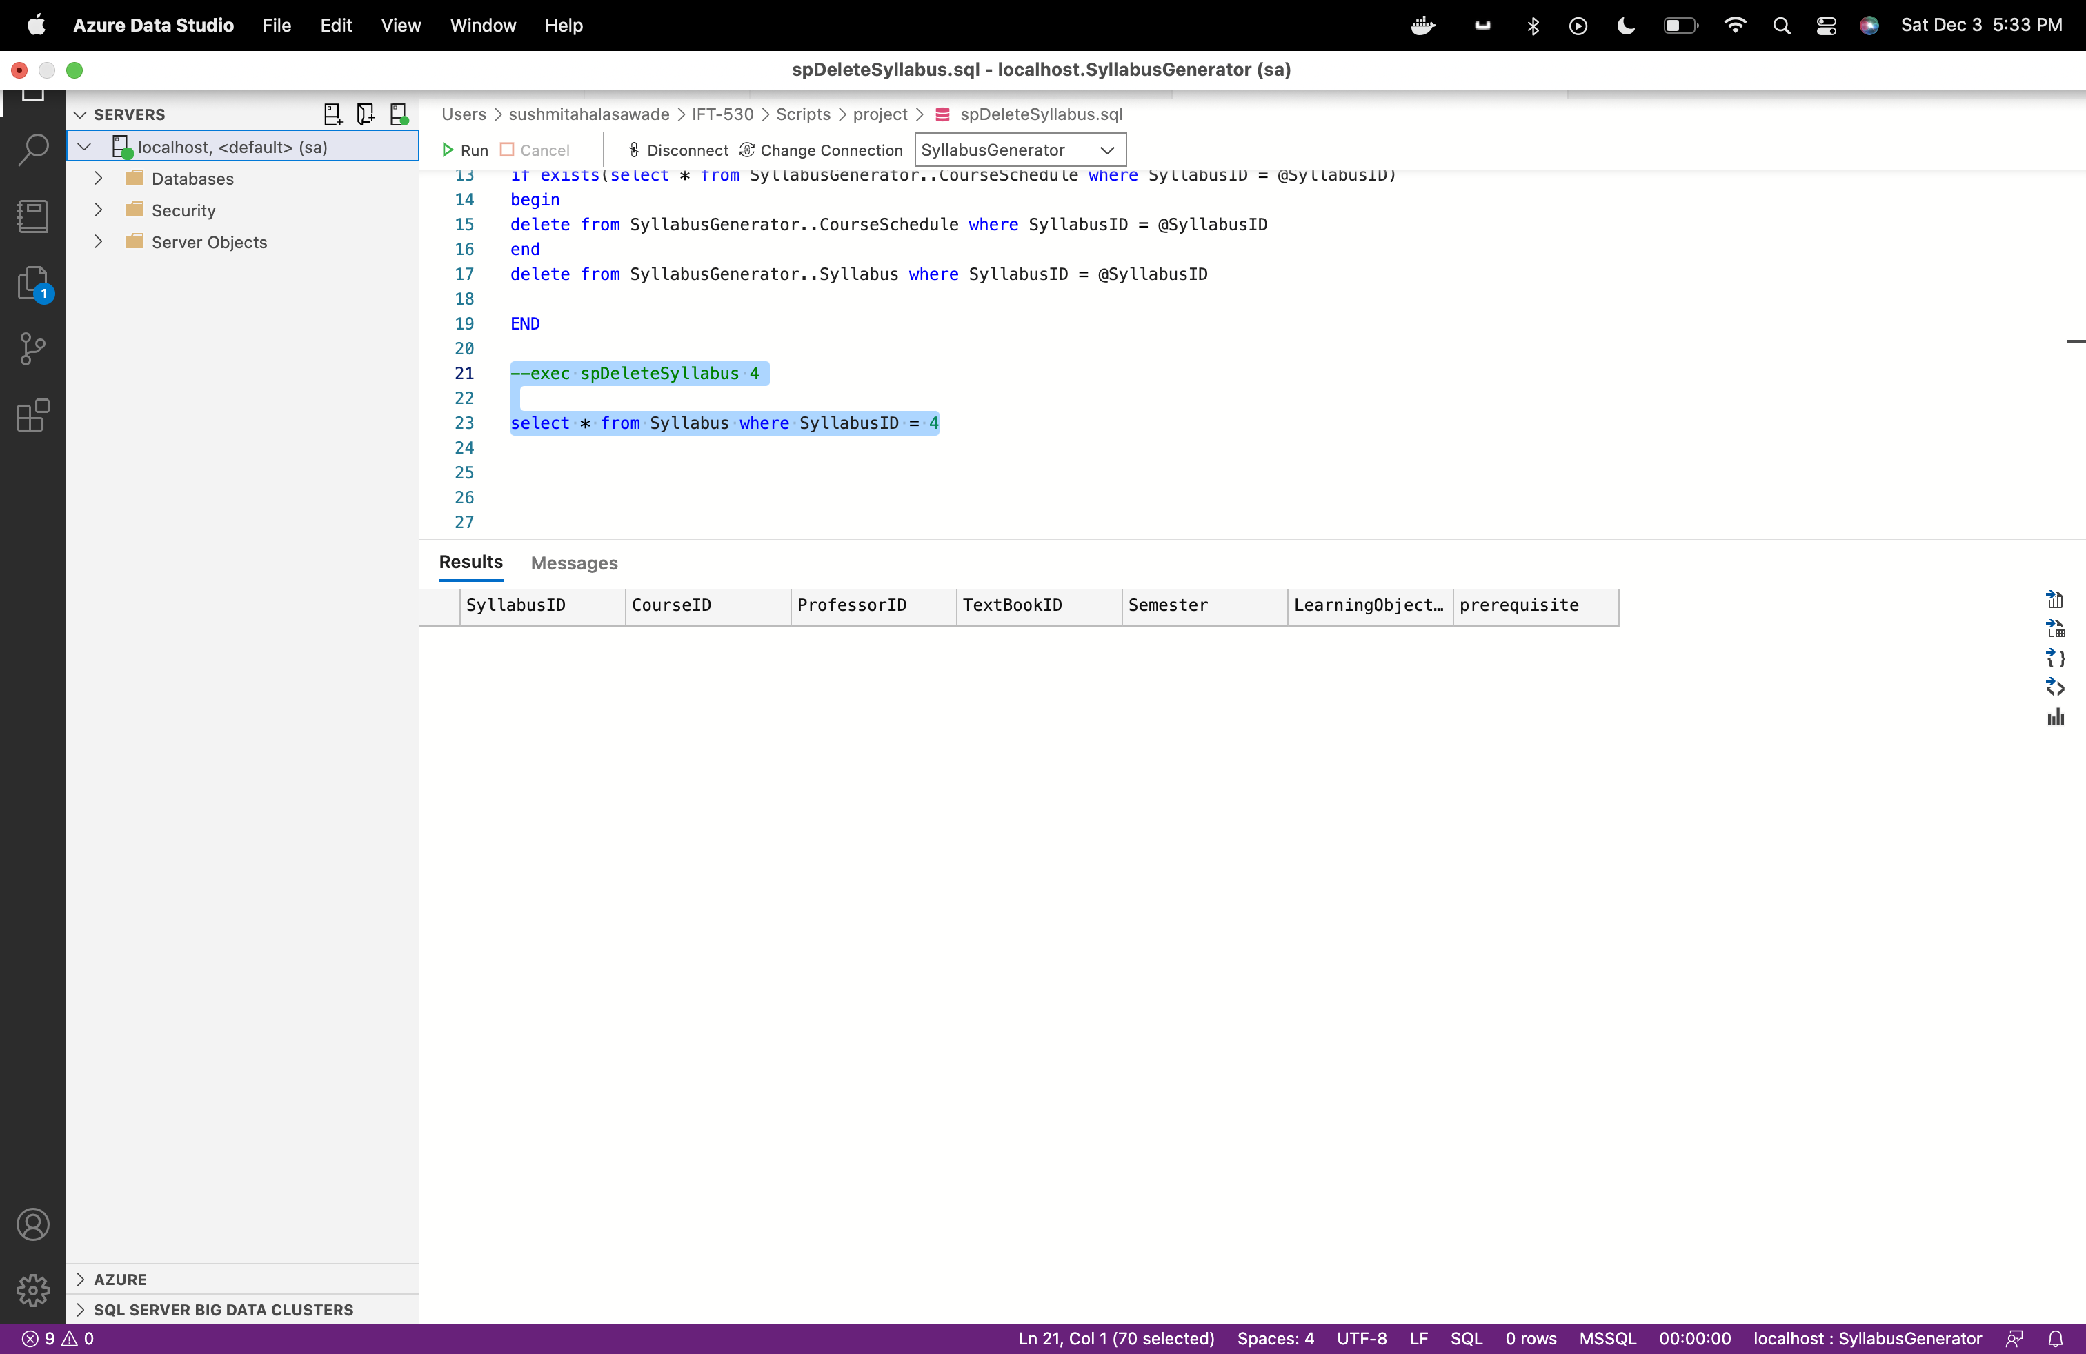

**Functions:**

1. **Get textbook requirements of course:**

Query:

USE SyllabusGenerator;

GO

CREATE or ALTER FUNCTION fnGettextbookdetails

(@SyllabusID int

)

RETURNS table

RETURN

(

select TextBookName,TextBookID from TextBook where textbookid in (select * from STRING_SPLIT((select TextBookID from Syllabus where SyllabusID = @SyllabusID), ','))

)

--select * from dbo.fnGettextbookdetails(1)

Output:

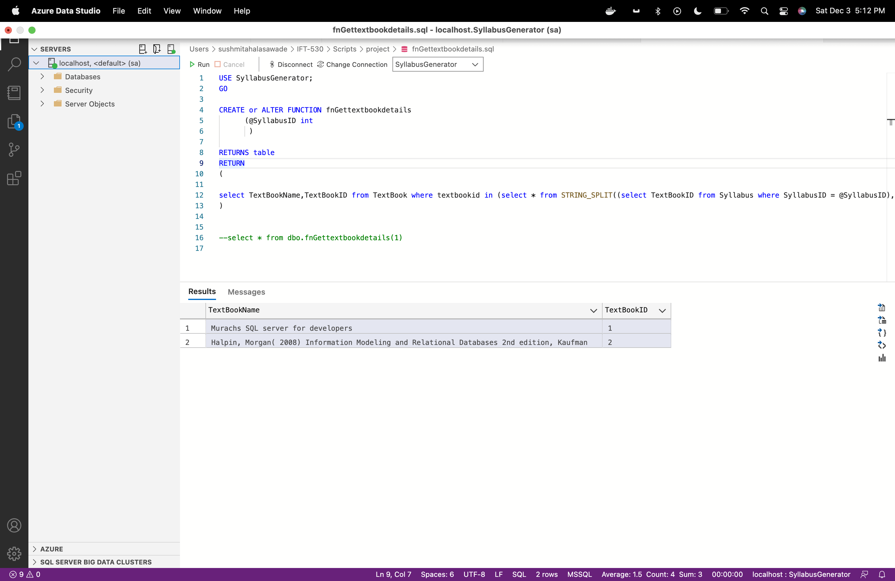

1. **Get prerequisite course list of course:**

Query:

USE SyllabusGenerator;

GO

CREATE or ALTER FUNCTION fnGetPrerequisite

(@SyllabusID int

)

RETURNS table

RETURN

(

select CourseID,CourseCode,CourseName from Course where CourseID in (select * from STRING_SPLIT((select prerequisite from Syllabus where SyllabusID = @SyllabusID), ','))

)

--select * from dbo.fnGetPrerequisite(1)

Output:

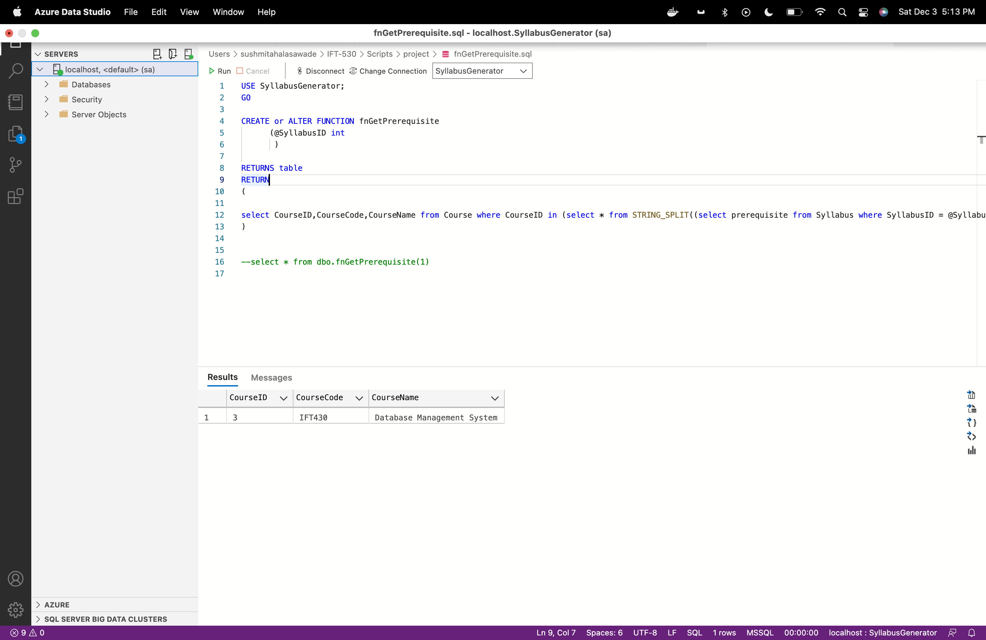

**Triggers:**

1. **Delete trigger to audit deleted syllabus.**

USE syllabusGenerator

GO

CREATE or alter TRIGGER trInsteadofDeleteSyllabus

on Syllabus

After DELETE

AS

declare @SyllabusID INT

declare @CourseID int

declare @ProfessorID int

declare @textbookid nvarchar(100)

declare @Semester nvarchar(10)

declare @LearningObjective nvarchar(max)

declare @prerequisite nvarchar(50)

select @SyllabusID= d.SyllabusID from deleted as d;

select @CourseID= d.CourseID from deleted as d;

select @ProfessorID= d.ProfessorID from deleted as d;

select @textbookid= d.TextBookID from deleted as d;

select @Semester= d.Semester from deleted as d;

select @LearningObjective= d.LearningObjective from deleted as d;

select @prerequisite= d.prerequisite from deleted as d;

Insert into SyllabusAudit (SyllabusID, CourseID, ProfessorID,textbookid,Semester,LearningObjective, prerequisite,Audit_action, Action_by, Action_At, Remark)

values(@SyllabusID,@CourseID,@ProfessorID,@textbookid,@Semester,@LearningObjective,@prerequisite,'DELETE',@ProfessorID,GETDATE(),'Deleted Syllabus')

print('Record deleted -Instead of Delete trigger')

Test:

select * from syllabus where syllabusid = 4;

select * from syllabusaudit ;

When we executed delete syllabys stored procedure for Syllabus with id = 4, the audit record is added in the table with after delete trigger.

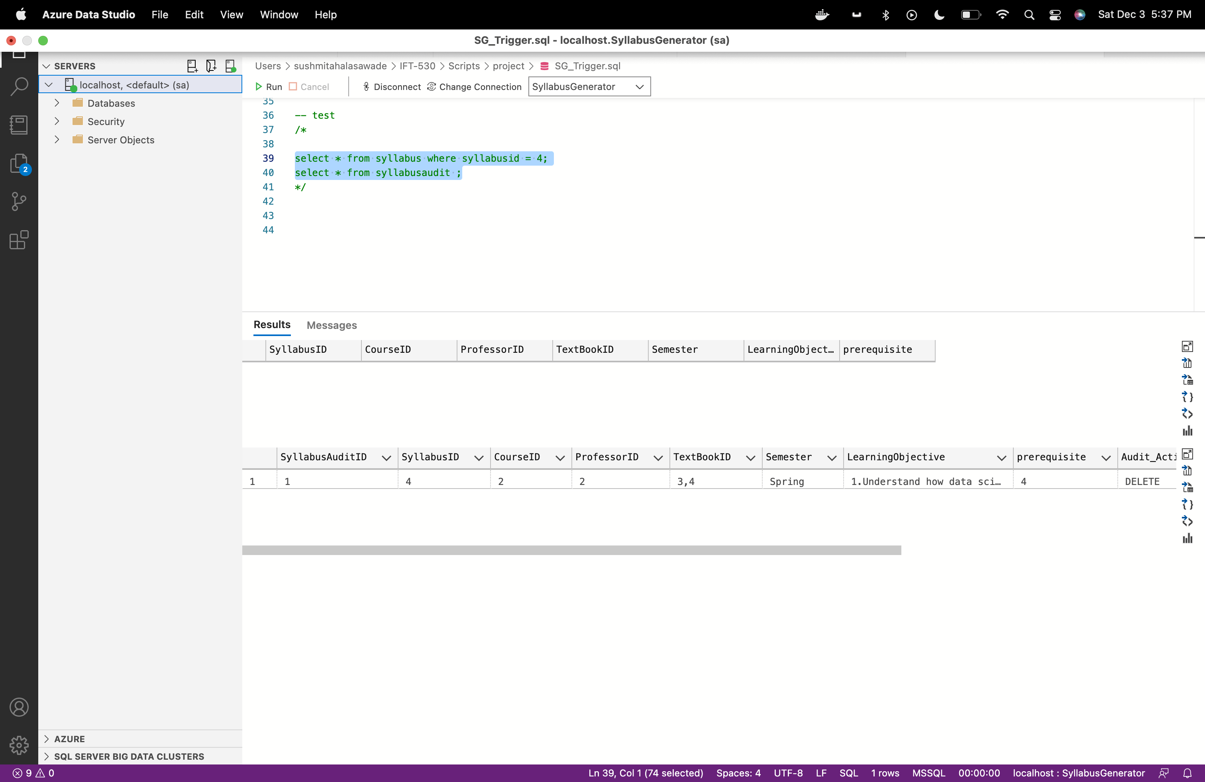

Update trigger

CREATE TRIGGER trAfterUpdateSyllabus

on dbo.Syllabus

For UPDATE

AS

declare @textbookid varchar(100)

declare @LearningObjective varchar(max)

declare @prerequisite varchar(100)

declare @description varchar(50)

declare @SyllabusID int

declare @CourseID int

declare @ProfessorID int

declare @Semester int

select @textbookid= i.textbookid from inserted as i;

select @LearningObjective= i.LearningObjective from inserted as i;

select @prerequisite= i.prerequisite from inserted as i;

select @SyllabusID= i.SyllabusID from inserted as i;

select @CourseID= i.CourseID from inserted as i;

select @ProfessorID= i.ProfessorID from inserted as i;

select @Semester= i.Semester from inserted as i;

IF UPDATE(textbookid)

SET @description = 'Updated textbookid of the syllabus'

IF UPDATE(LearningObjective)

SET @description = 'Updated LearningObjective of the syllabus'

IF UPDATE(prerequisite)

SET @description = 'Updated prerequisite of the syllabus'

Insert into SyllabusAudit (SyllabusID, CourseID, ProfessorID,textbookid,Semester,LearningObjective, prerequisite,Audit_action, Action_by, Action_At, Remark)

values(@SyllabusID,@CourseID,@ProfessorID,@textbookid,@Semester,@LearningObjective,@prerequisite,'UPDATE',@ProfessorID,GETDATE(),@description)

-- test

/*

update syllabus with (rowlock) set textbookid = '1,2' where syllabusid =1;

select * from Syllabus where syllabusid =1;

select top 1 remark, * from SyllabusAudit where syllabusid =1 order by action_at desc;

*/

